Name

Mathematics Stage 4
Properties of
Geometrical Figures

Book 1 |  | Version: 260909  Feedback:  https://MrDingMaths.com
Contents
Syllabus Content 2
Learning Intention 3

Syllabus Content
MA4-GEO-C-01 identifies and applies the properties of triangles and quadrilaterals to solve problems
Classify triangles according to their side and angle properties
- Label triangles using appropriate text and symbols
- Classify and describe types of triangles based on their properties, including acute-angled, right-angled, obtuse-angled, equilateral, isosceles and scalene triangles
Classify quadrilaterals and describe their properties
- Identify quadrilaterals using naming conventions
- Distinguish between convex and non-convex quadrilaterals
- Verify and describe the properties of the special quadrilaterals which include parallelograms, rectangles, rhombuses, squares, trapeziums and kites
- Identify and label the properties of the special quadrilaterals using appropriate conventions
- Classify quadrilaterals based on their properties
- Justify why some quadrilaterals may be classified as more than one type of quadrilateral
Apply the properties of triangles and quadrilaterals
- Prove that the interior angle sum of a triangle is 180° with or without digital tools
- Prove that any exterior angle of a triangle equals the sum of the 2 interior opposite angles
- Apply the angle sum of a triangle to prove that the angle sum of a quadrilateral is 360°
- Apply the properties of triangles and quadrilaterals to determine unknown sides and angles to solve problems, giving reasons

Classifying Triangles

- Labelling Triangles
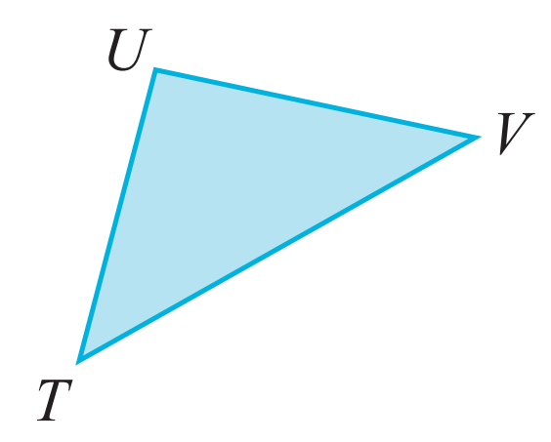
- We label triangles according its its three vertices.
- Name the vertices in clockwise order.

$ΔTUV$

- Classifying Triangles According to Angle Properties
Right-Angled Triangle | Acute-Angled Triangle | Obtuse-Angled Triangle
One angle is 90$°$ | All angles acute (<90$°)$ | 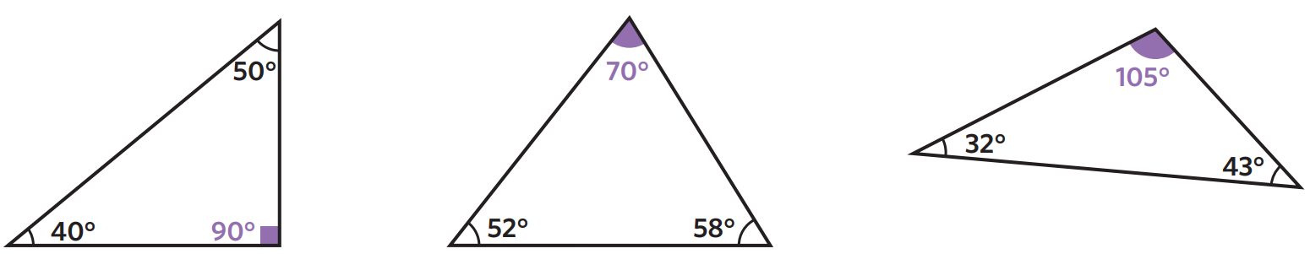  One angle obtuse (>90$°)$

- Classify triangle based on angle property
Classify these triangles as right-angled, acute, or obtuse.
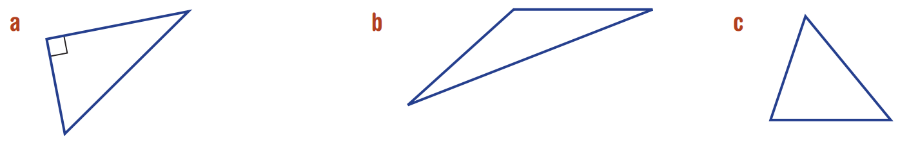

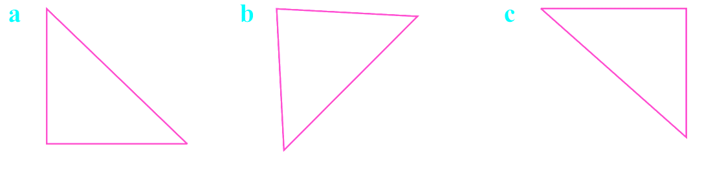

- Classifying Triangles According to Angle Properties
Equilateral Triangle | Isosceles Triangle | Scalene Triangle
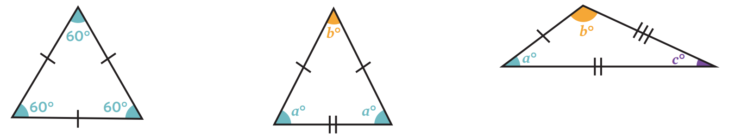  All sides the same length  All angles the same (60$°$) | Two side lengths equal  Two angles the same | All three sides different.  All angles different.

- Classify triangle based on side property
Classify these triangles as equilateral, isosceles, or scalene.
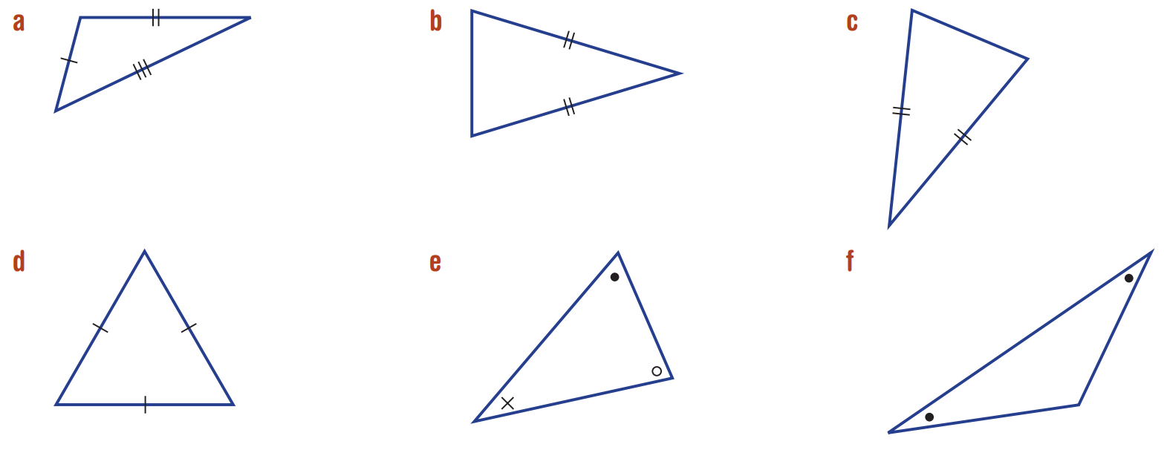

Foundation
- Classify these triangles. Circle every description that matches.
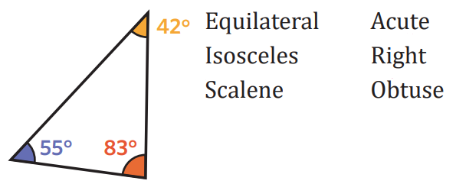  Scalene, acute | 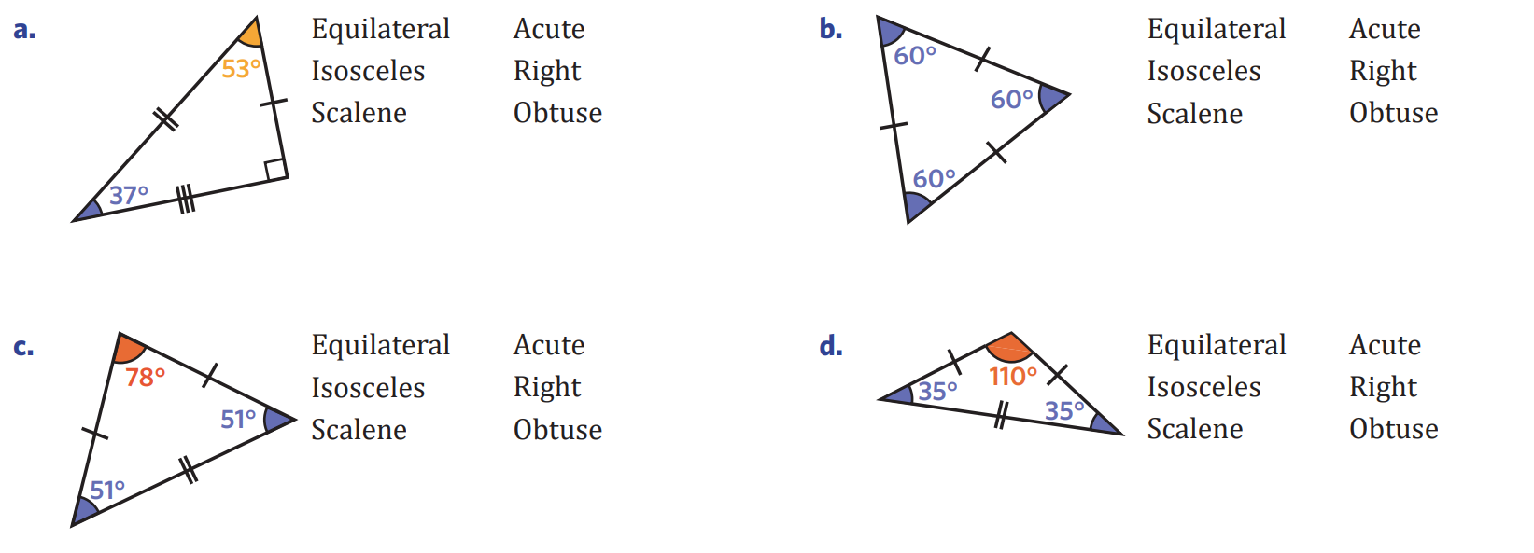  Scalene, right
Equilateral, acute | Isosceles, acute
Isosceles, obtuse | 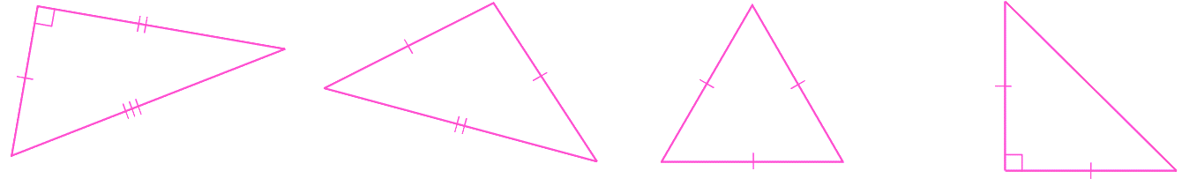  Scalene, right
Isosceles, right | $$95°$$  Isosceles, obtuse
Equilateral, acute | 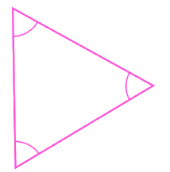  Equilateral, acute
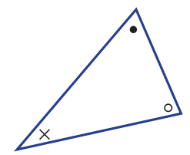  Scalene, acute | 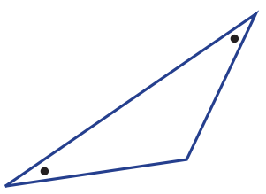  Isosceles, obtuse

- Explain why every equilateral triangle is also an acute triangle.
………………………………………………………………………………………………………………
………………………………………………………………………………………………………………
Equilateral triangles have all angles 60°, so it is an acute triangle.

- Categorise each triangle below into one of the table cells.
 | Isosceles | Equilateral | Scalene
Acute | C | I, B | E, G
Right | F |  | A
Obtuse | D |  | H
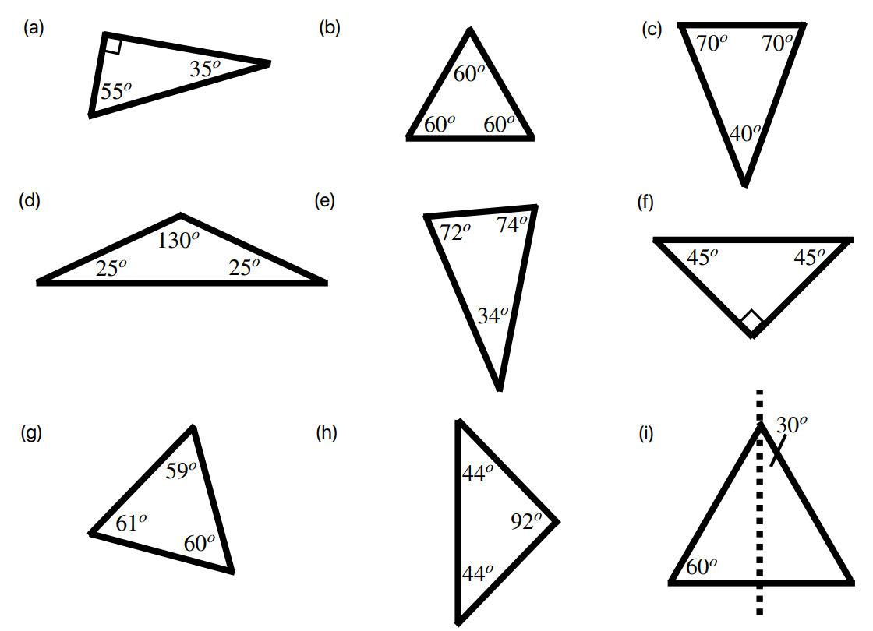
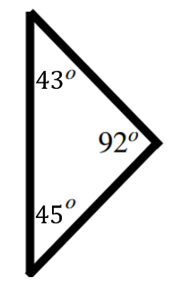

  - Explain why the ‘equilateral column’ has two blank boxes.

All equilateral triangles are acute.
  - Identify the type of triangle based on the following information:
    - A triangle with all sides and angles equal …………………………………………
Equilateral
    - A triangle with no sides equal …………………………………………
Scalene
    - A triangle with one angle 91 …………………………………………
Obtuse
    - A triangle with angles 103, 20, 57 …………………………………………
Scalene, obtuse
    - A triangle with sides 11, 15, 11 …………………………………………
Isosceles

- Draw the triangles given by these descriptions,
- $Δ$ABC isosceles  with AB = BC  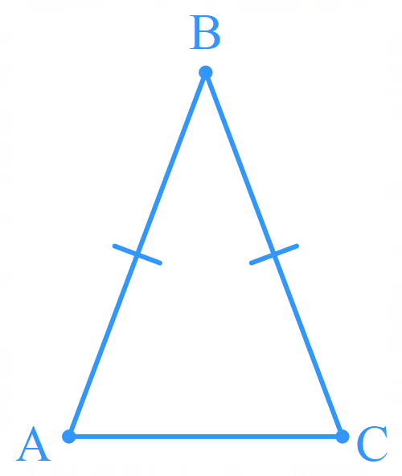 | - $Δ$ABC, isosceles  with AB = AC  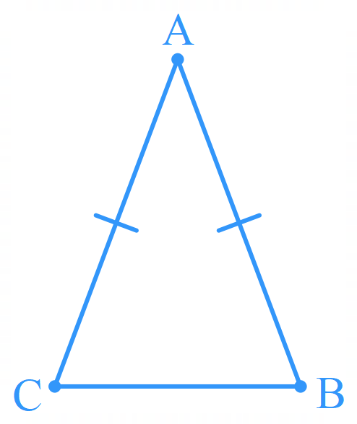 | - $Δ$XYZ, isosceles,  $∠$ZXY = $∠$ZYX  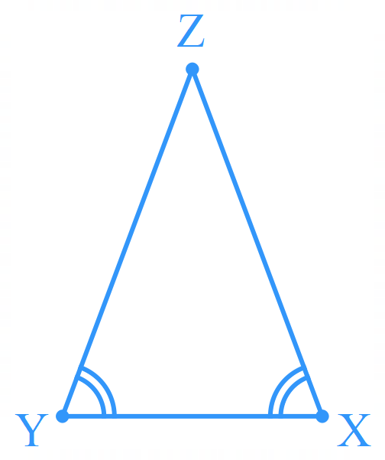
- $Δ$PQR, scalene  not right-angled  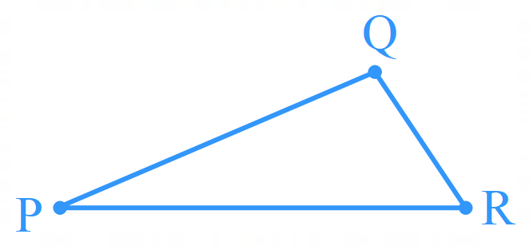 | - $Δ$PQR, scalene with a right angle at $∠$RPQ  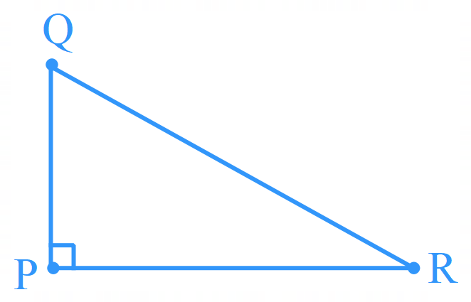 | - $Δ$XYZ, equilateral  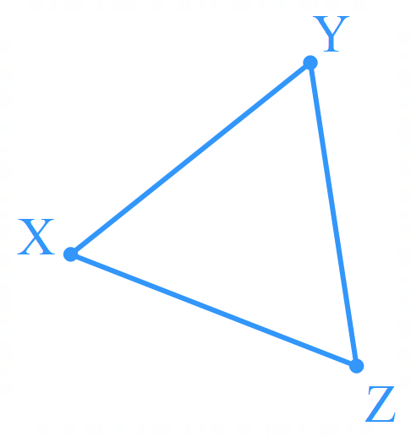

Angle Sum of a Triangle

- Angle Sum of a Triangle
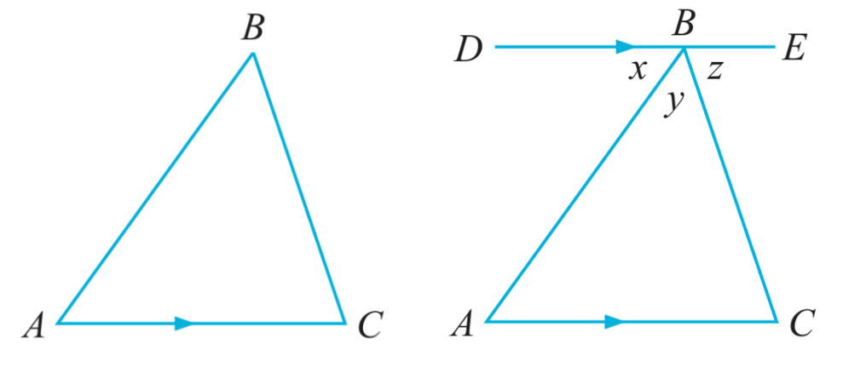
Consider the triangle $ΔABC$:
Construct line $DBE$ parallel to $AC$.

By considering $∠DBE:$ $x+y+z=$ ………$°$ (…………………………………………………)
$∠DBA=$ $∠BAC$ (……………………………………………………)
$∠EBC=$ $∠$……… (alternate angles on parallel lines)
By considering the sum of the angles in $ΔABC$:
$x+y+z=$ ………$°$

- Angle Sum of a Triangle
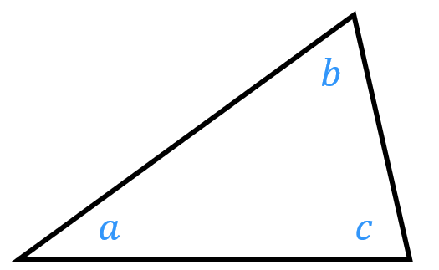

$a+b+c=180°$

- Write an equation using angle relationships.
- Simplify the equation, if needed.
- Solve for the unknown using inverse operations.

- Example Solve problems involving angle sum of a triangle
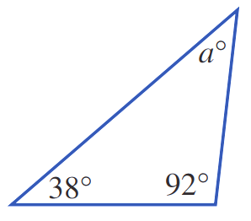  1. $a+38+92=180$ (angle sum of triangle)  2. $a+130=180$  3. $a=50°$ | 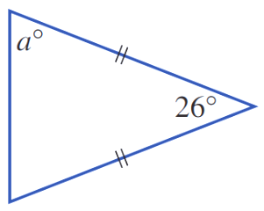  1. $a+a+26=180$ (angle sum of triangle)  2. $2a+26=180$  3. $2a=154$  $a=77°$

- Guided Practice
Find the value of the pronumerals in these diagrams.
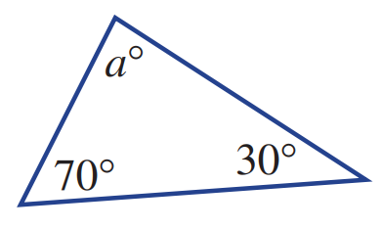  $a$ + $70$ + $30= 180$  $a=80°$ | 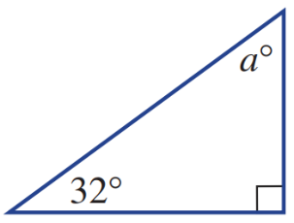  …… + …… + …… = 180  $a=58°$
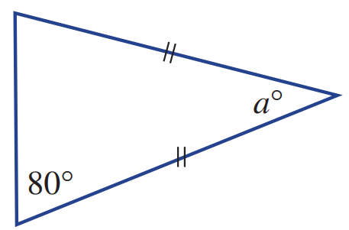  $a=20°$ | 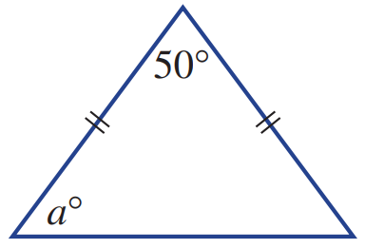  $a=65°$

Foundation
- Use the angle sum of a triangle to find the value of the pronumeral. Show full working out.
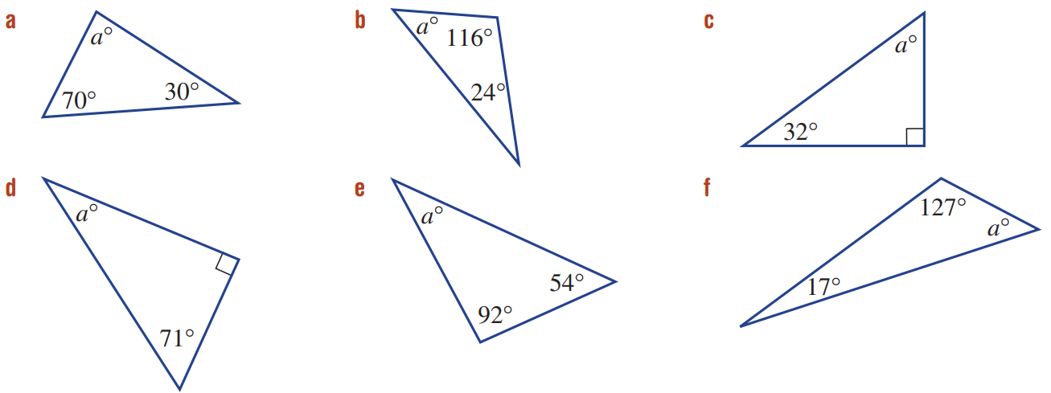  $$a+30+70=180$$  $$a=80°$$ | $$a=40°$$ | $$a=58°$$
$$a=19°$$ | $$a=34°$$ | $$a=36°$$

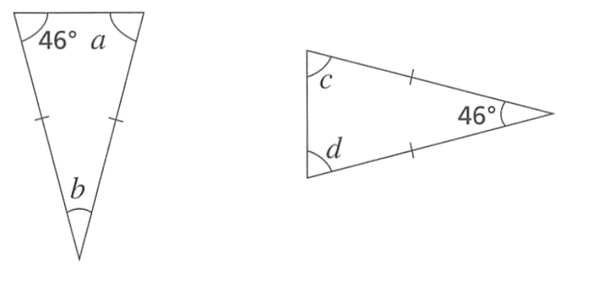
- Both of the triangles shown are isosceles.

  - What part of the diagram tells you the triangles are isosceles?

The dashes
  - Determine the value of the missing angles $a,b,c,d$.

$$a=46°$$
$$b=88°$$
$$c=d=67°$$
  - Explain why angles $a$ and $b$ are different to $c$ and $d$, even though both triangles have similar information.

In the first triangle, 46° was one of the equal angles.
In the second triangle, $46°$ was the non-equal angle.

Development
- Use the angle sum of a triangle to find the value of the pronumeral in these isosceles triangles.
You do not need to show working out.
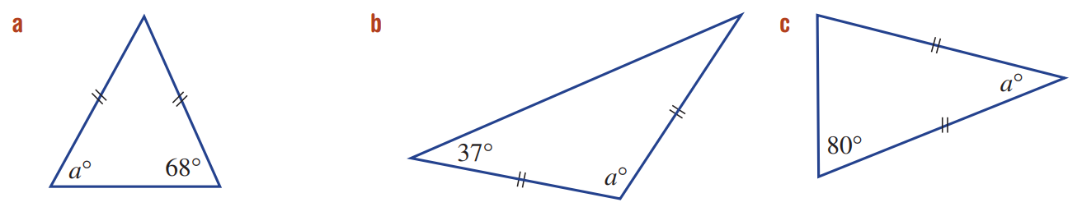  68° | 106° | 20°
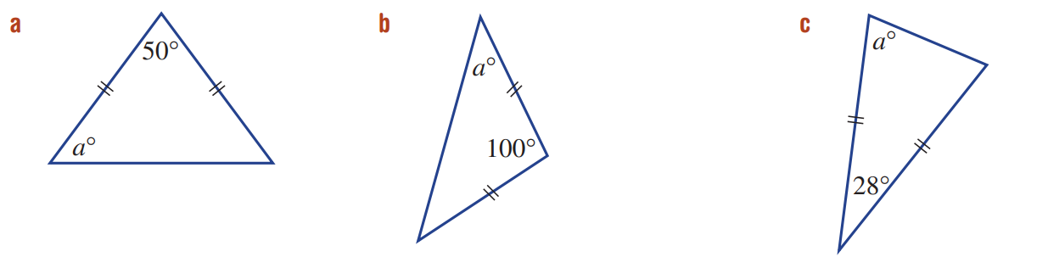  65° | 40° | 76°

- Determine the value of the unknown angles in these triangles.
You do not need to show working out.
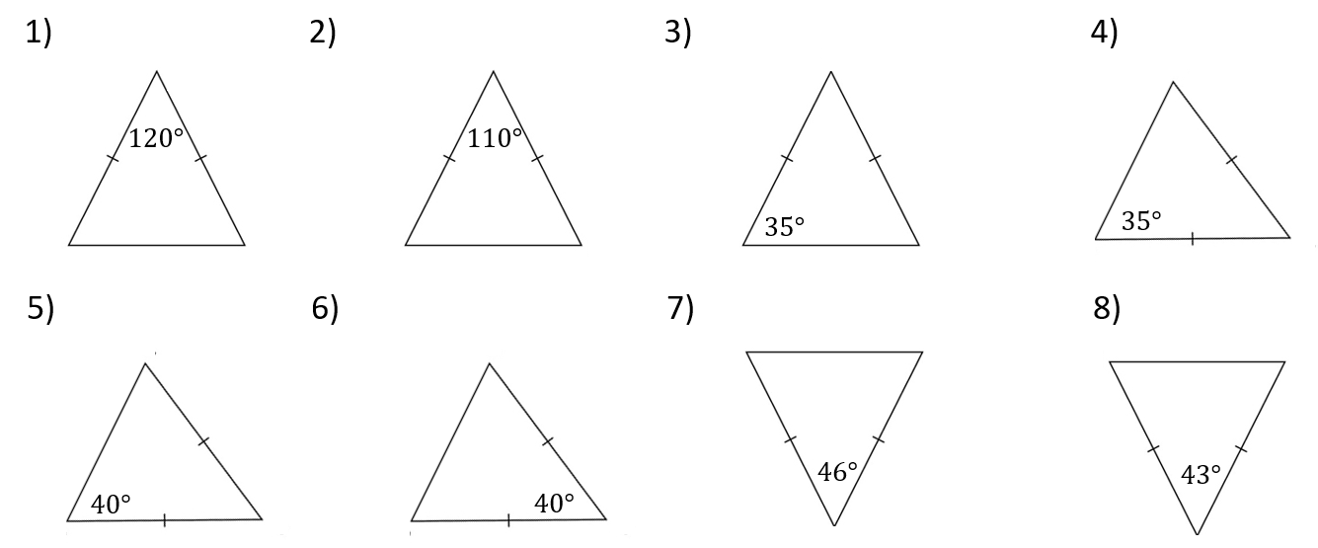  30, 30 | 35, 35 | 110, 35
35, 110 | 40, 100 | 70, 70
67, 67 | 68.5, 68.5 | 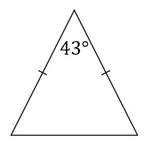  68.5, 68.5

- Two of the angles in a triangle are 74° and 104°. Work out the size of the third angle.

$$a=74+74=180°$$
$$a=2°$$
- Use algebra to explain why every angle is an equilateral triangle is $60°$.
$$x$$
$$x$$
$$x$$

$$3x=180°$$
$$x=60°$$
- One of the angles in an isosceles triangle is 80°. Work out the sizes of the other two angles.

If 80° is the non-equal angle, then the other angles are 50°
If 80° is one of the equal angles, then the other angle is 20°
Explain why there are two possible sets of answers.

The question doesn’t specify whether 80° is one of the equal angles or not
- One of the angles in an isosceles triangle is 160°. Work out the sizes of the other two angles.

Other two angles are both 10°
Explain why there is only one possible set of answers.

160° can’t be one of the equal angles because it would exceed the angle sum of a triangle
- An isosceles triangle has an interior angle of $60°$. Find all the other angles.

The other two angels are 60°
What do you notice?

If an isosceles triangle has 60°, it must be equilateral

Mastery
- Provide full reasoning for both parts below.
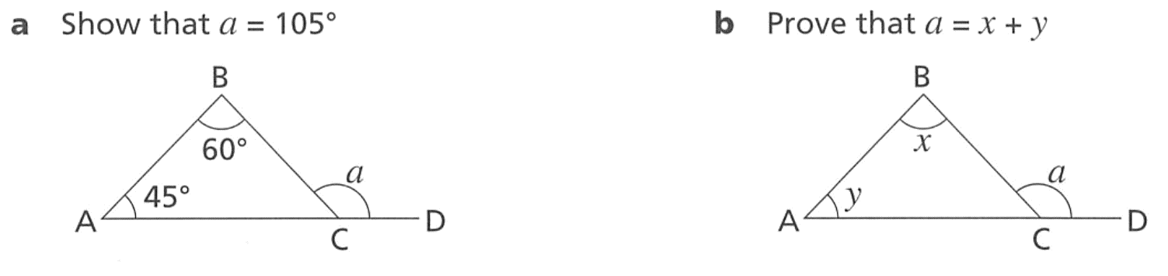  - Show that $a=105°$  $∠ACB=75°$ (angle sum of a triangle)  $$a=180-75=105°$$  (angles on a straight line supplementary) | - Prove that $a=x+y$  $∠BCA=180-x-y$ (angle sum of trangle)  $a=180-(180-x-y)$ (angles on a straight line)  $$a=x+y$$

- Determine the value represented by the pronumeral. You do not need to show working out.
$$x=66°$$ | 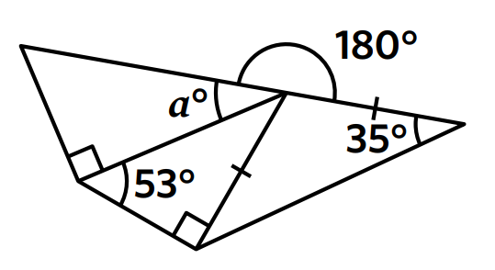  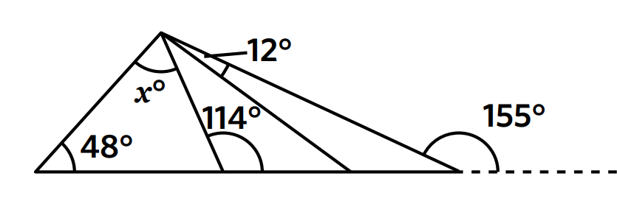  $$a=33°$$
- Determine the size of the missing angles in each diagram.
You do not need to show working out.
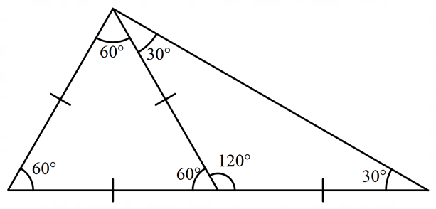  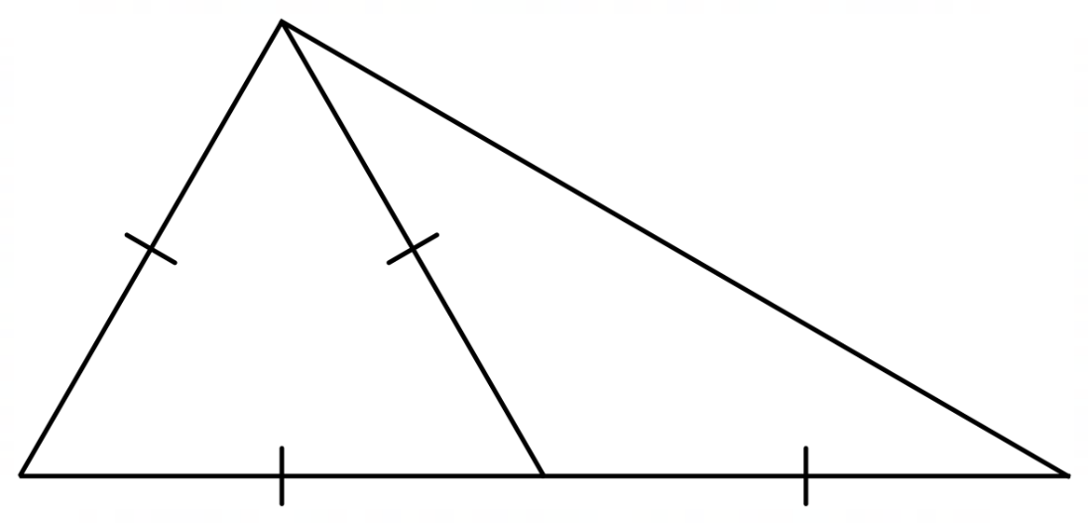 | 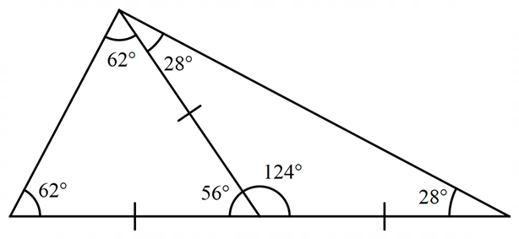  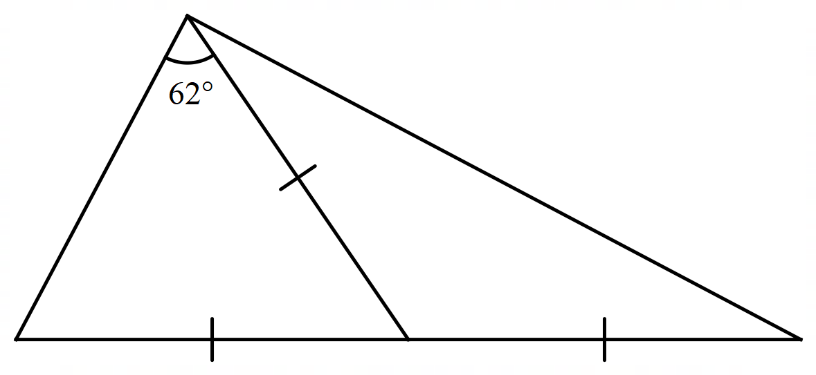
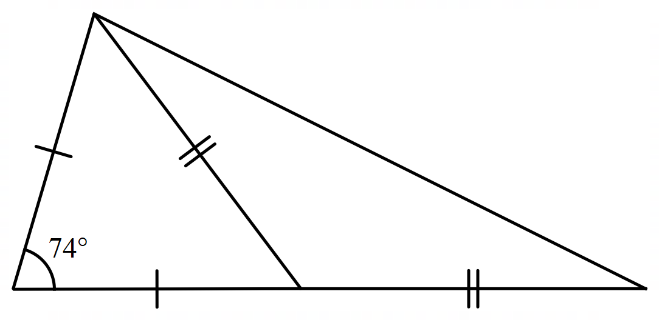  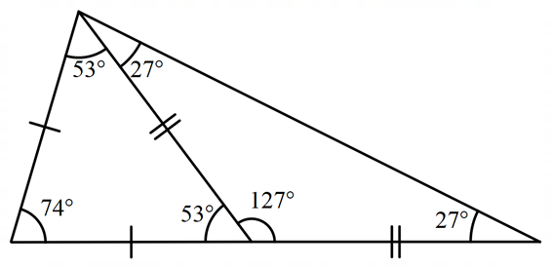 | 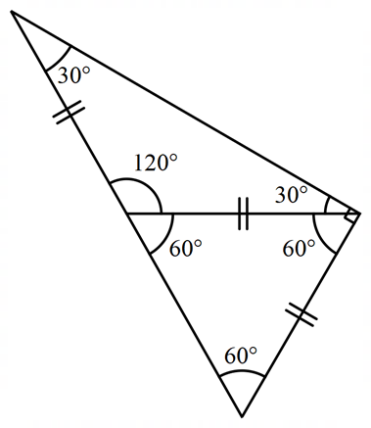  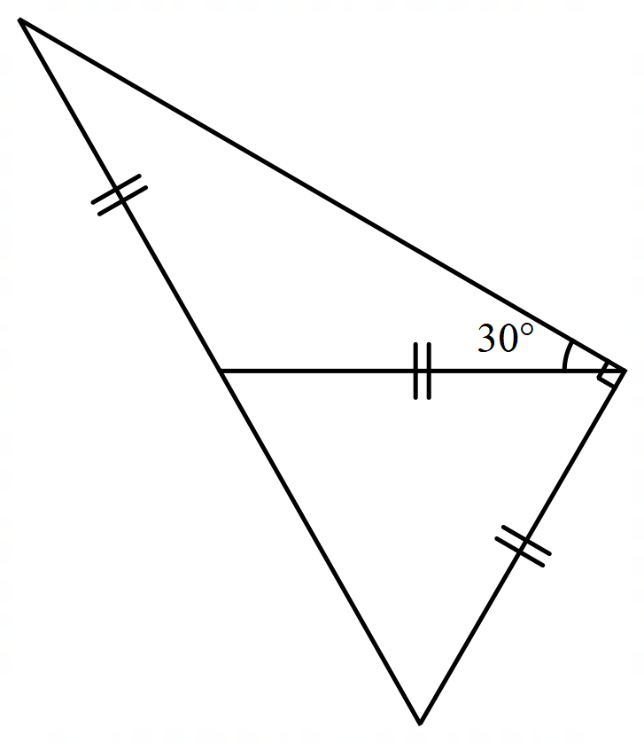

- Decide whether the triangles shown are isosceles.
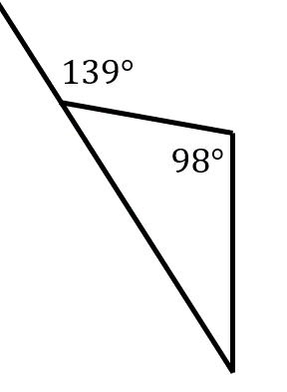  yes | 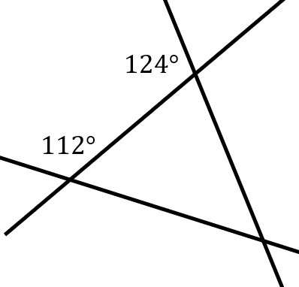  yes

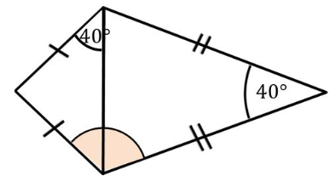  - Find the size of the shaded angle.  110° | - Find the size of angle $p$.  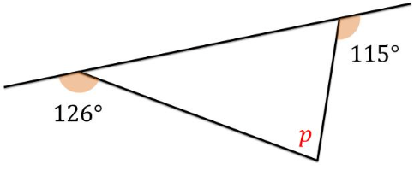  61°
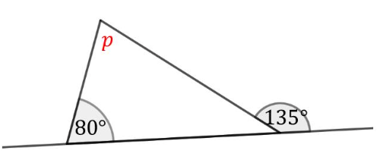  - Find the size of angle $p$.  55° | 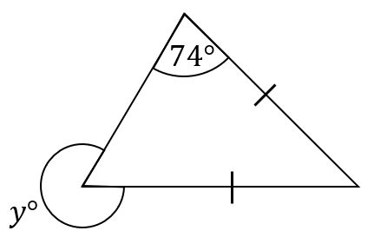  - Find the size of angle $y$.  286°
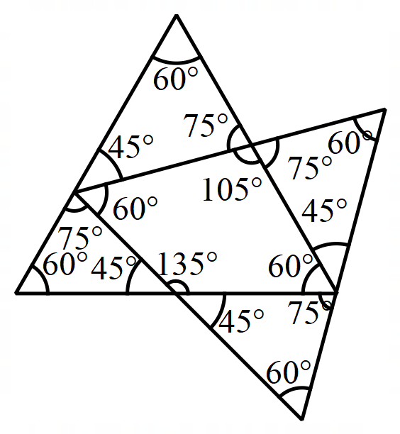  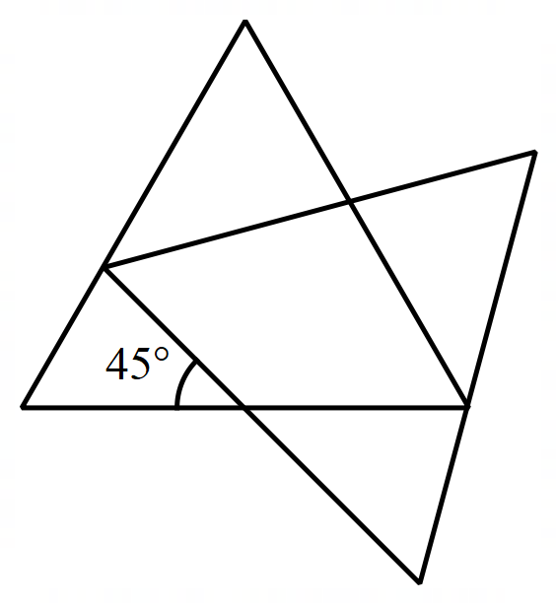  - This is a pair of overlapping equilateral triangles. Find every angle. | 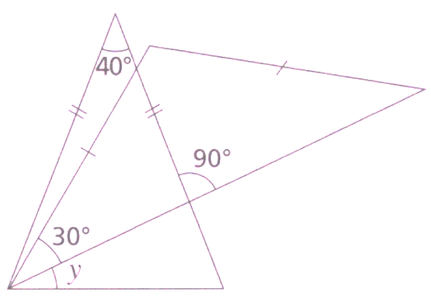  - The is a pair of isosceles triangles.  Work out the size of angle $y$.  20°
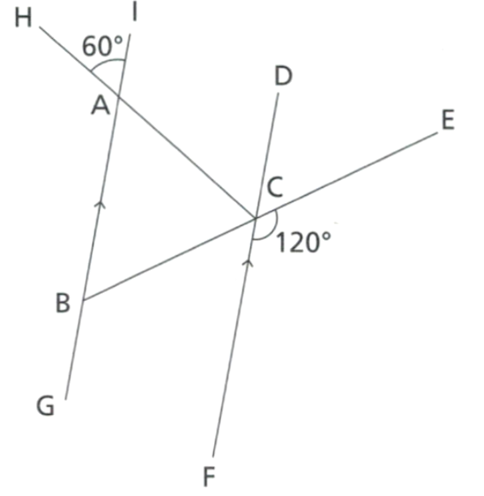
- Show that triangle ABC is equilateral. Give full reasoning for each stage of your working.

∠BAC = 60° (vertically opposite)
∠BCF = 60° (angles on straight line)
∠ABC = ∠BCF (alternate angles on parallel lines)
= 60°
∠ACB = 180° - 60° - 60° (angle sum of △)
= 60°
∴ △ABC is equilateral.
- Determine the value of the pronumerals in these diagrams.
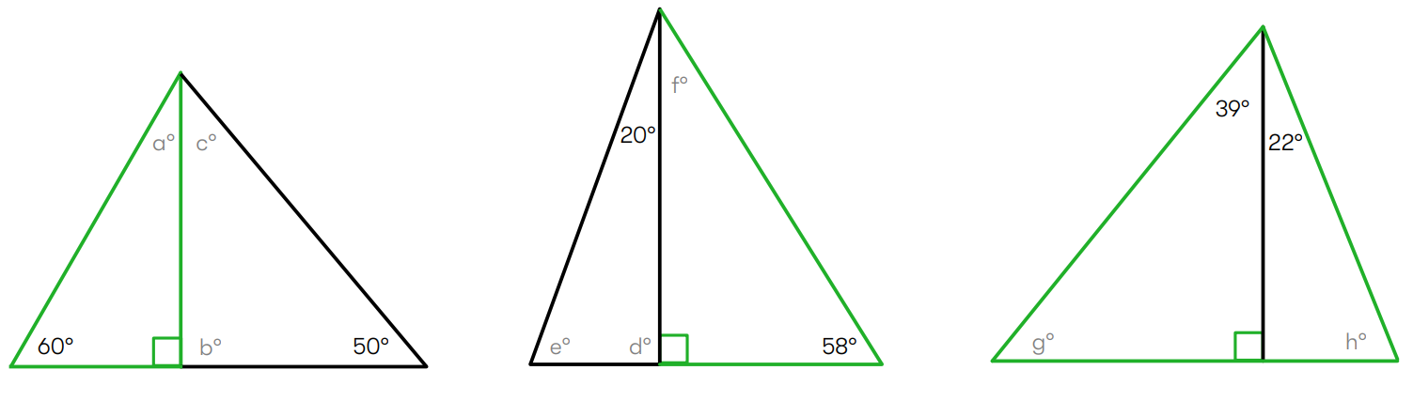  $$a=30, b=90, c=40$$ | $$d=90, e=70, f=32$$ | $g=51, h=68$
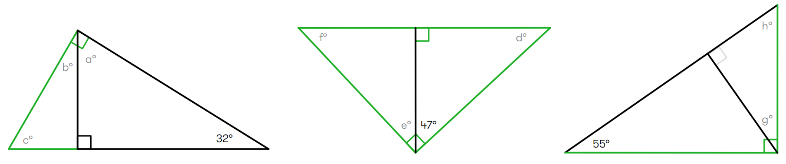  $$a=58, b=22, c=58$$ | $$d=43, e=43, f=47$$ | $$g=55, h=35$$
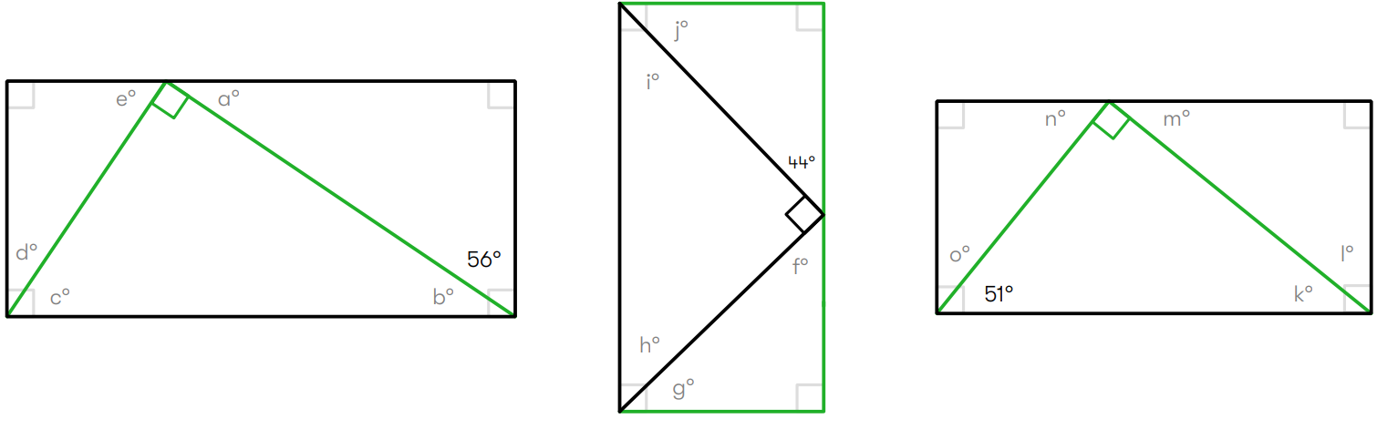  $$a=34,b=34, c=56,d=34,e=56$$ | $$f=46, g=44, h=46, i=44, j=46$$ | $$k=39,l=51,m=39,n=51,o=39$$
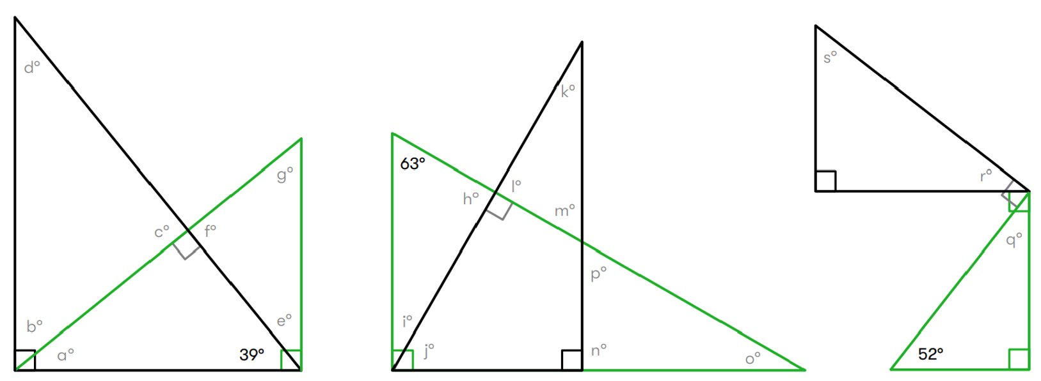  $$a=51,b=39,c=90$$  $$d=51,e=51,f=90,g=39$$ | $$h=90,i=27,j=63,k=27,l=90,$$  $$m=63,n=90,o=27,p=63$$ | $$q=38, r=38, s=52$$

Exterior Angle Theorem

- Exterior Angle of a Triangle
If we extend one side of a triangle, we make an exterior angle.
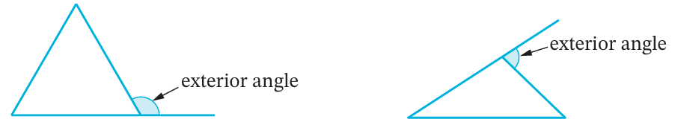

- Exterior Angle Theorem
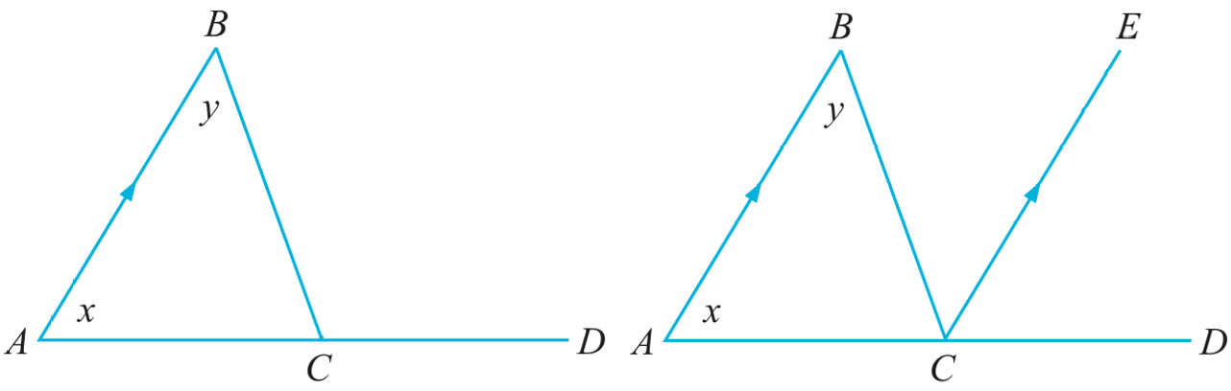
Consider triangle $ΔABC$ with exterior angle $∠BCD.$
Construct line $CE$ parallel to $AB$

$∠BAC=∠ECD$ (………………………………………)
$∠ABC=∠$ …… (alternate angles on || lines)
$∴∠BCD=$ ……… $+$ …………
The exterior angle of a triangle is equal to the ……… of the two opposite interior angles.

- Exterior Angle Theorem
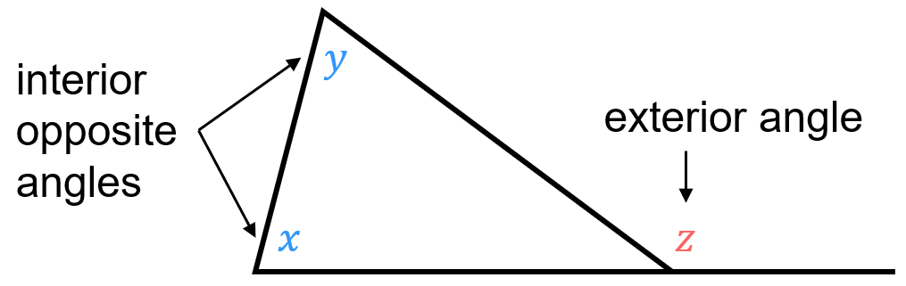

$$x+y=z$$

- Identify Exterior angles and interior opposite angles
Indicate the two interior angles opposite the exterior angle $x$ in these diagrams
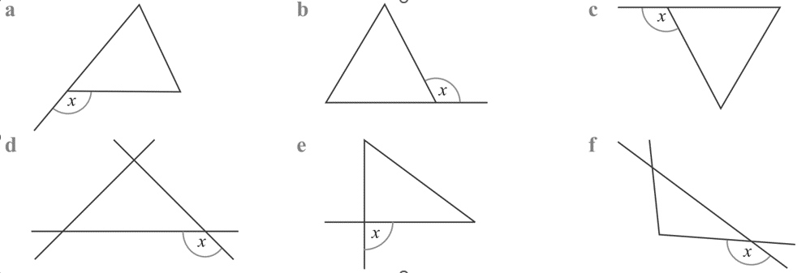

For each triangle, write an equation using exterior angle theorem.
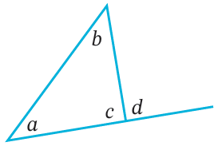  $a$ $+$ $b=$ ……… | $a$ $+$ $b=$ ……… | $a$ $+$ $b=$ ………

- Key Ideas
- The exterior angle of a triangle is the …………… of the two interior opposite angles.

- Example Solve problems involving the exterior angle theorem
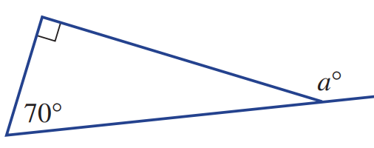  1. $90+70=a$ (exterior angle theorem)  3. $160°=a$ | 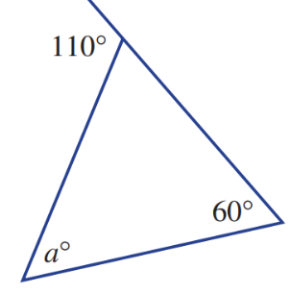  1. $a+60=110$ (exterior angle theorem)  3. $a=50°$

- Guided Practice
Find the value of the pronumeral in these diagrams.
$x=$ ……… + ………  $=$ ……………  $x=110°$ | 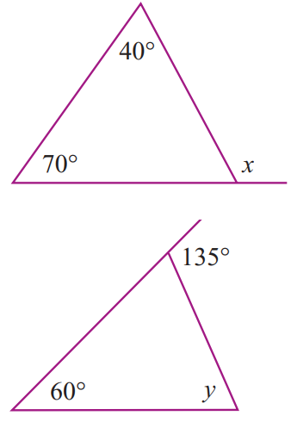  ……… $+ y=$ ………  $y=$ ………  $y=75°$
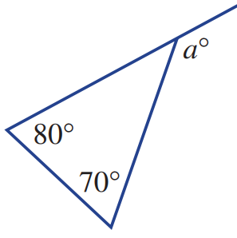  $a=150°$ | 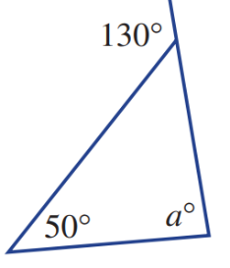  $a=80°$

Foundation
- Calculate the value of the missing exterior angle using exterior angle theorem.
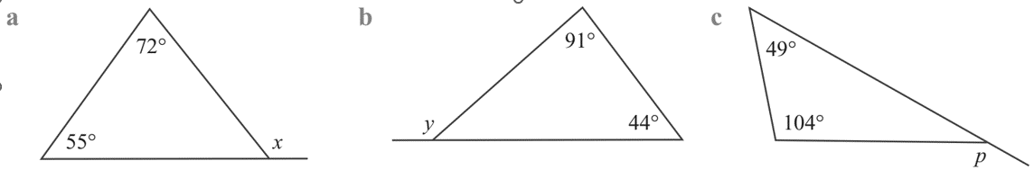  $x=$…… $+$ ……  $=$ ……………  127° | 135° | 153°

- Calculate the value of the missing interior angle using exterior angle theorem.
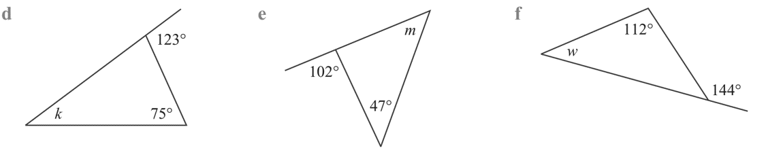  …… $= k$ $+$ ……  …… $=$ $k$  48° | 55° | 32°

- Calculate the value of the pronumeral. You do not need to show reasoning.
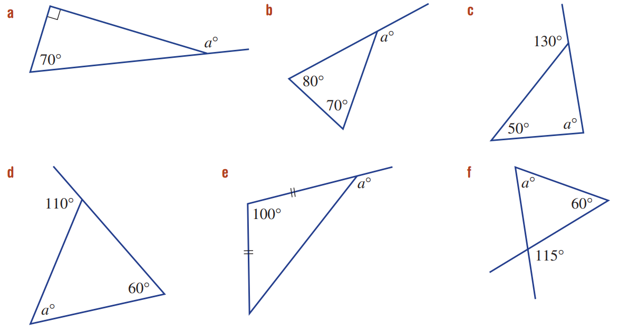  160° | 150° | 80°
50° | 140° | 55°

Development
- Find the value of each pronumeral, you do not need to show reasoning.
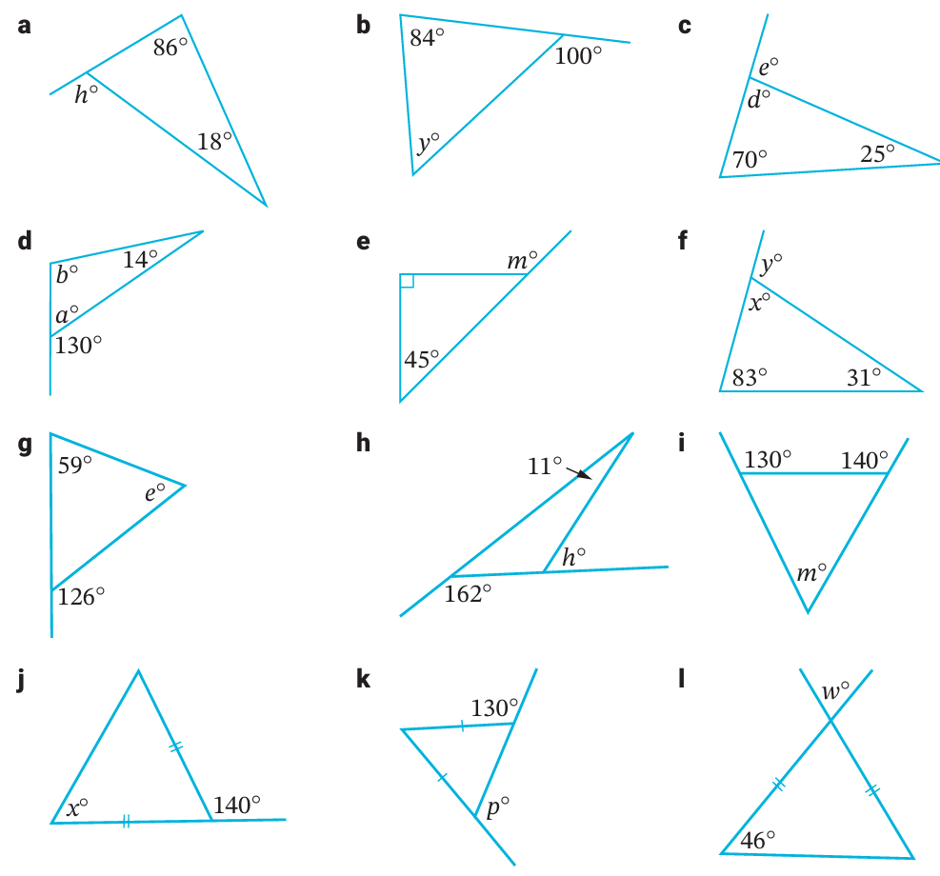  104 | 16 | $$d=85, e=95$$ | $$a=50, b=116$$
135 | $$x=66, y=114$$ | 67 | 29
90 | 70 | 130 | 88

- Determine the value of the pronumeral, using all the angle relationships you know.
You do not need to show reasoning.
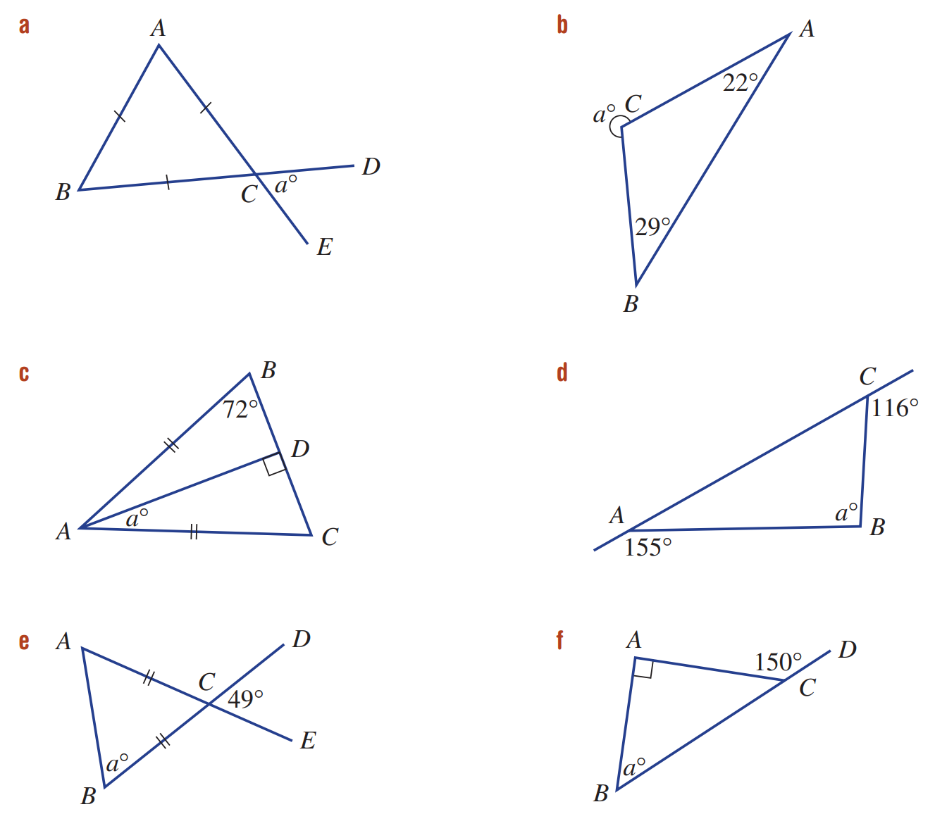  60 | 231 | 18
91 | 65.5 | 60
- Determine all the missing angles in this diagram.
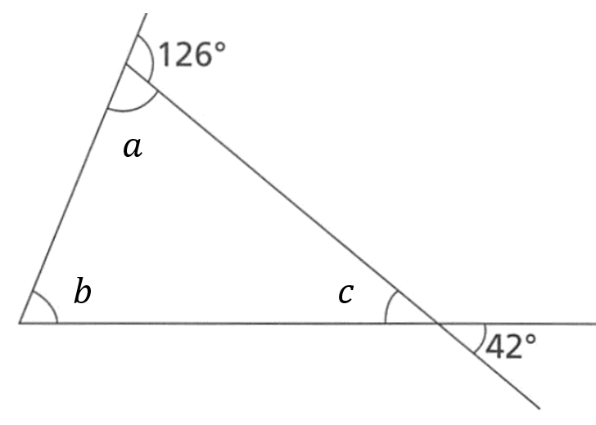

$$a=54°$$
$$b=84°$$
$$c=42°$$
- Use your knowledge of angle relationships on parallel lines to calculate the unknown angles.
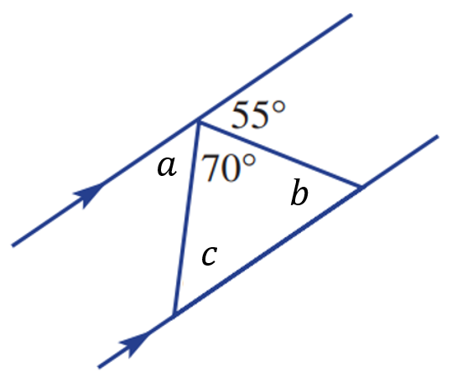  $$a=55°, b=55°, c=55°$$ | 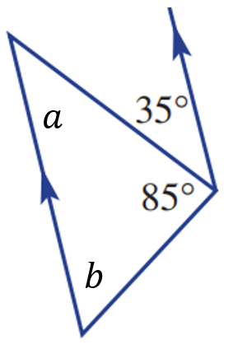  $$a=35°, b=60°$$ | 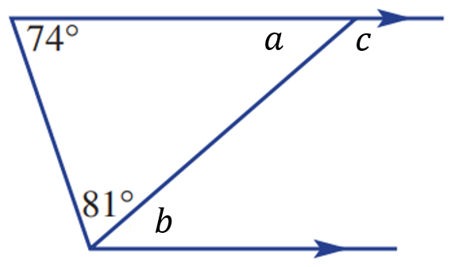  $$a=25°, b=25°, c=155°$$

- By writing an equation, solve for the pronumeral.
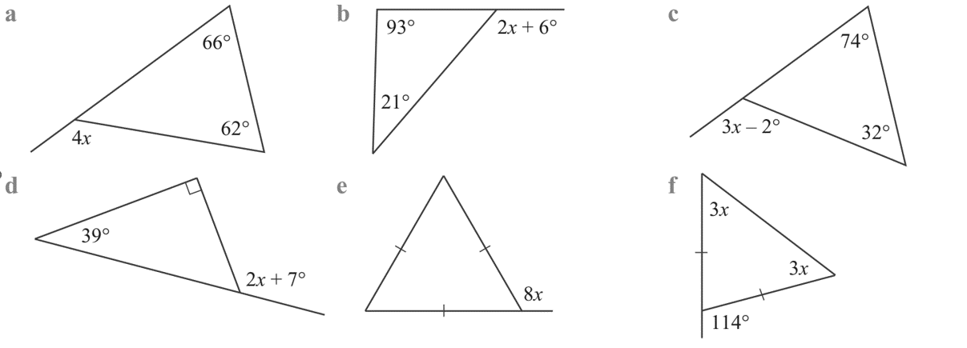  $$4x+52=180$$  32° | $$2x+72=180$$  54° | $$3x+72=180$$  36°
$$2x+7=129$$  61° | $$8x+60=180$$  15° | $$6x=114$$  14°

Mastery
- $∠PRQ=48°$ and $∠TSP=141°$. Determine the sizes of every angle.
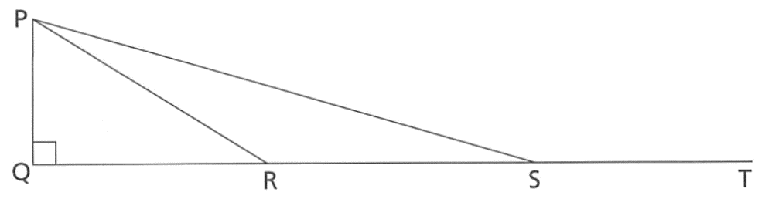

$$∠QPR=42°$$
$$∠PRS=132°$$
$$∠RSP=39°$$
$$∠RPS=9°$$
- Show these properties, using full reasoning.
- Show that triangle $ABC$ is equilateral.  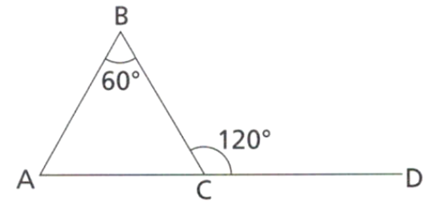  ∠BAC=120−60 (exterior angle theorem)  = 60°  ∠BCA=180−120 (angles on a straight line)  = 60°  ∴△ABC is equilateral. | 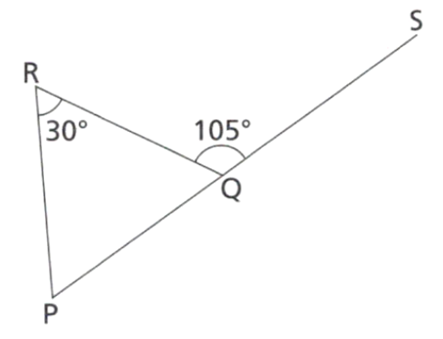  - Show that triangle $PQR$ is isosceles.  ∠RPQ=105−30 (exterior angle theorem)  = 75°  ∠RQP=180−105 (angles on a straight line)  = 75°  ∠RPQ=∠RQP  ∴△PQR is isosceles.

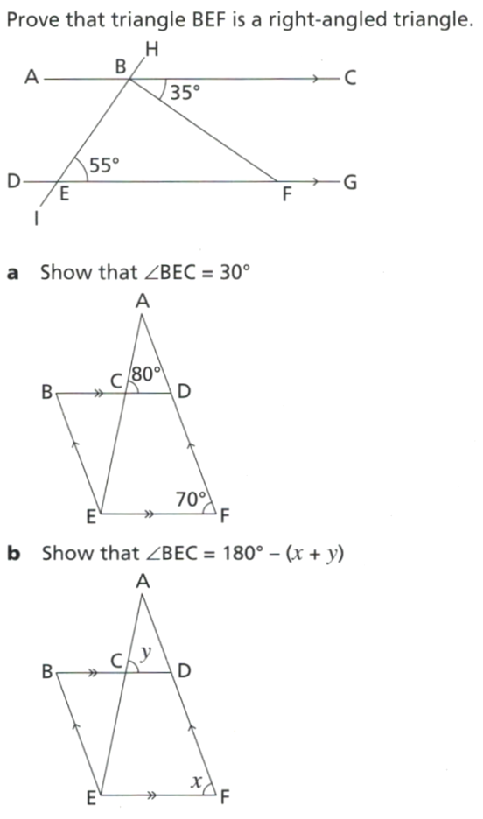
- Prove that $ΔBEF$ is a right-angled triangle, giving full geometrical reasoning.

∠CBF=∠BFE=35° (alternate angles on parallel lines)
∠EBF=180−55−35
= 90° (angle sum of triangle)
∴△BEF is right-angled
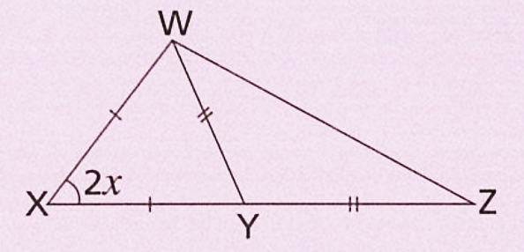
- Find expressions, in terms of $x$, for all the angles in this triangle.
(Hint: simplify the expressions as you go)

$$∠XWY=∠XYW=90-x$$
$$∠WYZ=90+x$$
$$∠YWZ=∠WZY=45-\frac{x}{2}$$
- Another proof of the alternate angle theorem is possible by using the angle sum of a triangle.
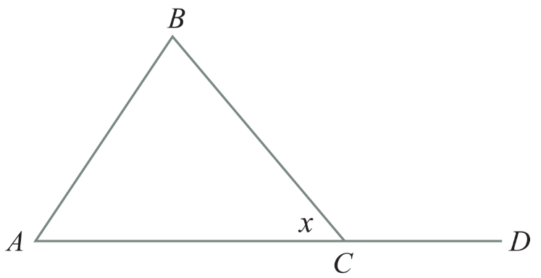

By considering $ΔABC,$ $x$ $+$ $∠BAC$ $+$ $∠ABC=$ $180$ (…………………………………………)

Angle sum of $Δ$
$∠BAC+∠ABC=180-$ ………
$$x$$
By considering $∠ACD$, $x+$ $∠BCD$ $=$ ………… (……………………………………………)
$180$ (angles on straight lines)
$∠BCD=$ ………………
$$180-x$$
To summarise:
$$∠BAC+∠ABC=180-x \\ ∠BCD=180-x$$
So ………………… $=$ ………………
$$∠BAC+∠ABC=∠BCD$$

Features of Quadrilaterals

- Labelling Quadrilaterals
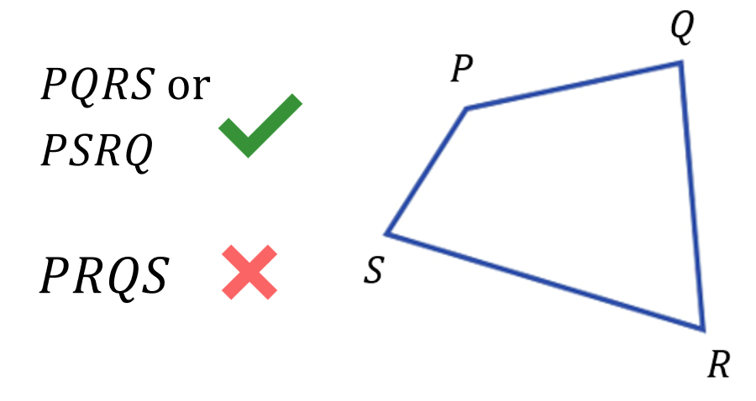
- A quadrilateral is a 4-sided shape.
- We label quadrilaterals using their vertices.
- Write vertices in clockwise or anticlockwise order.

- Label quadrilaterals
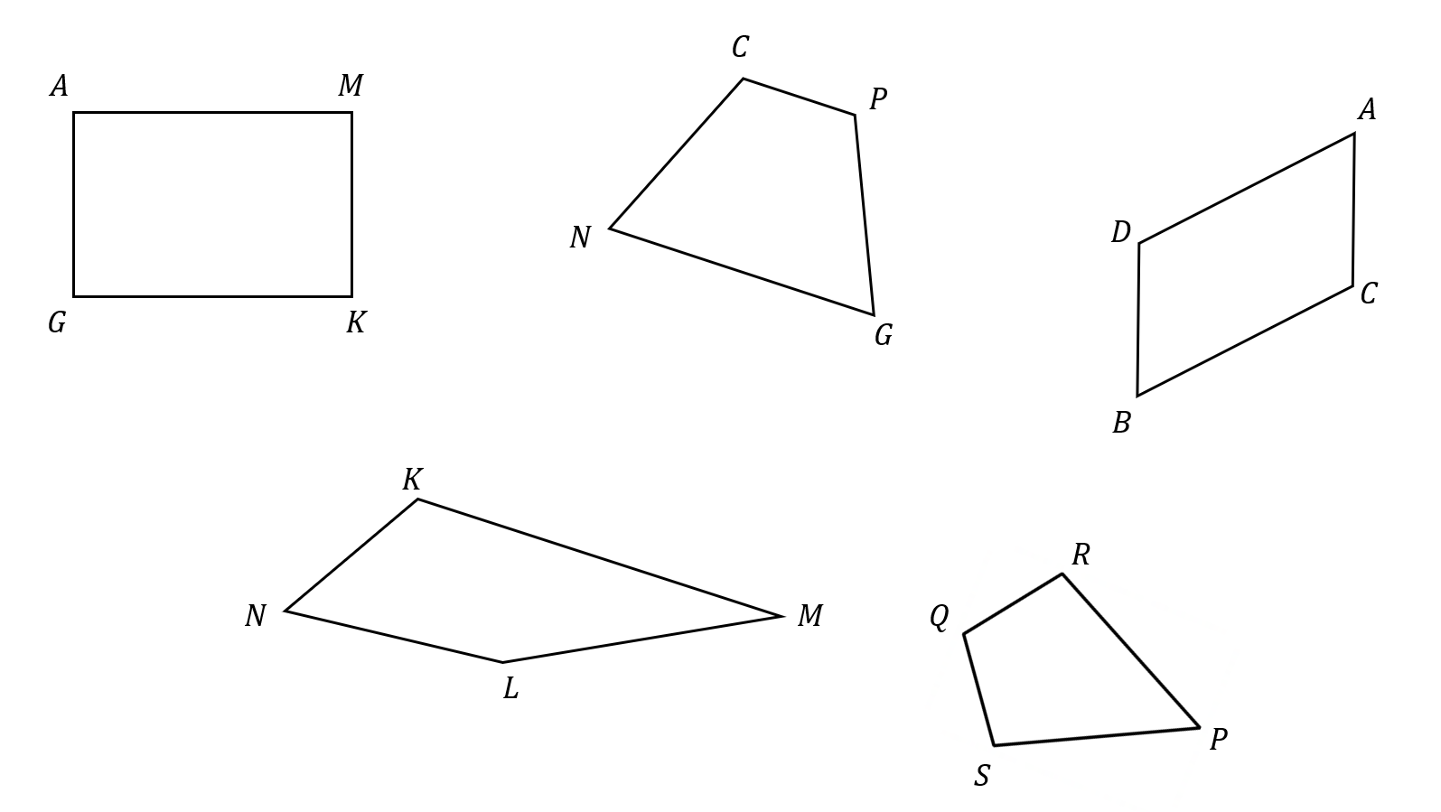

- Tommy was asked to draw a rectangle $ABCD$. This is what he sketched.
Explain why he is incorrect, and draw rectangle $ABCD$ correctly.
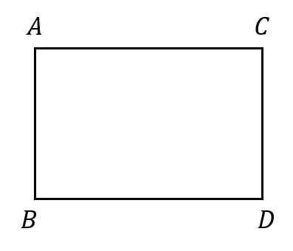

- Diagonals
- Adjacent means next to.
- An edge of a polygon joins two adjacent vertices.
- A diagonal of a polygon joins two non-adjacent vertices.
- A diagonal goes from one corner to another, skipping at least one corner.
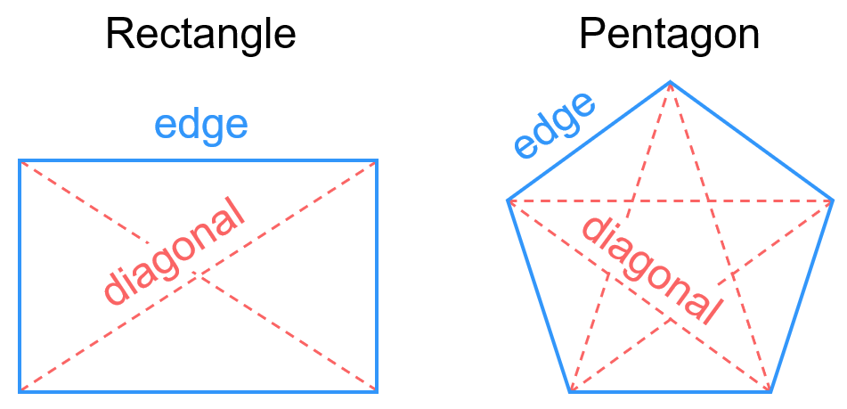

- Draw Diagonals of a polygon
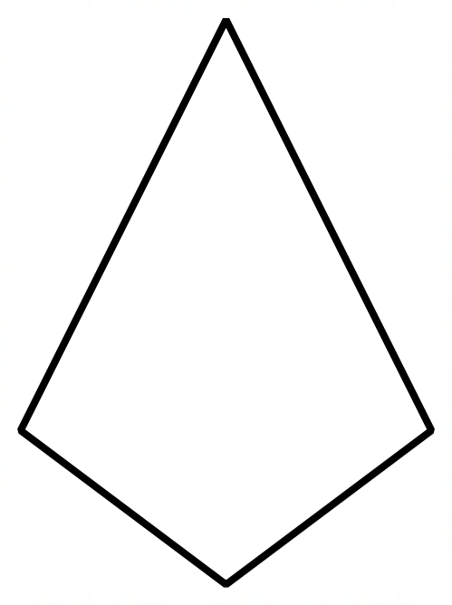

- Convex and Non-Convex Quadrilaterals
Convex  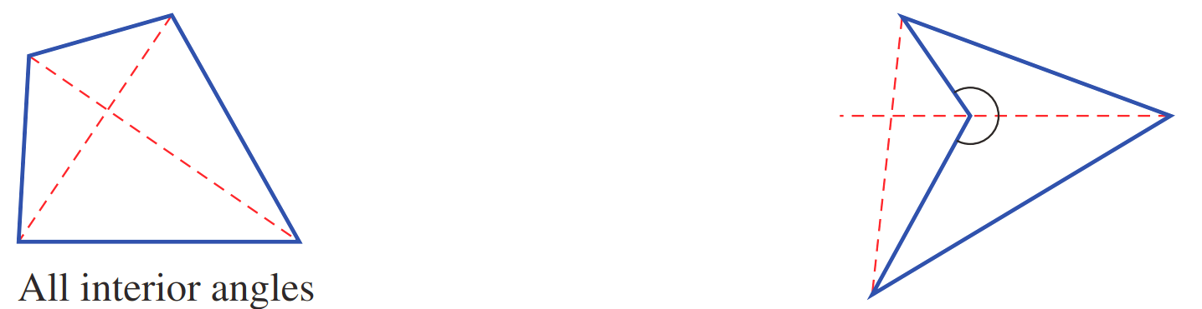  All interior angles less than $180°$  Diagonals meet inside the quadrilateral. | Non-Convex  At least one interior reflex angle (>$180°$)  Diagonals meet outside the quadrilateral.

- Identify Convex and Non-Convex Quadrilaterals
Determine whether these quadrilaterals are convex or non-convex by drawing the diagonals.
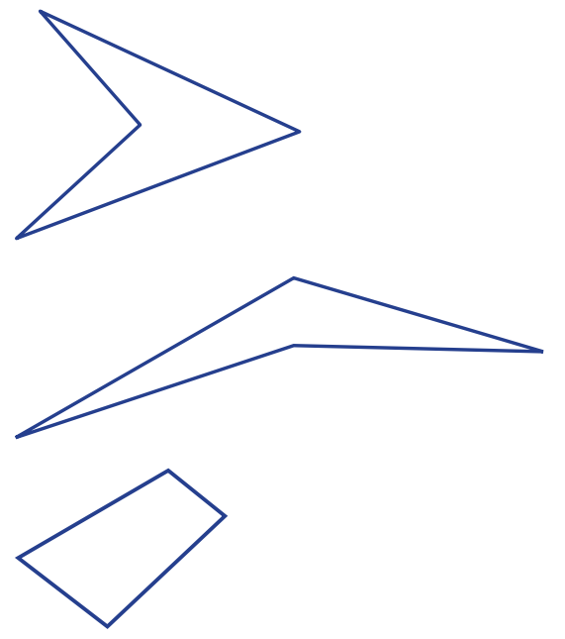

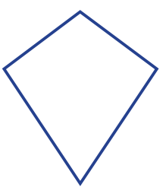

Properties of Special Quadrilaterals

- Properties of Special Quadrilaterals
Adjacent means next to. Bisect means cut into two equal parts.
Using the notation on the diagrams, or the GeoGebra links, fill in the table.
- Properties of a Square: https://www.geogebra.org/m/xq7pbnpe
- Properties of a Rectangle: https://www.geogebra.org/m/axwkzwq6
- Properties of a Rhombus: https://www.geogebra.org/m/wtu2b73s
- Properties of a Parallelogram: https://www.geogebra.org/m/gmhdqgbn
- Properties of a Parallelogram: https://www.geogebra.org/m/qem8ddkv
- Properties of a Trapezium: https://www.geogebra.org/m/h2kxb78k

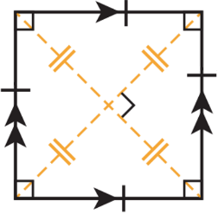  Square | Rectangle  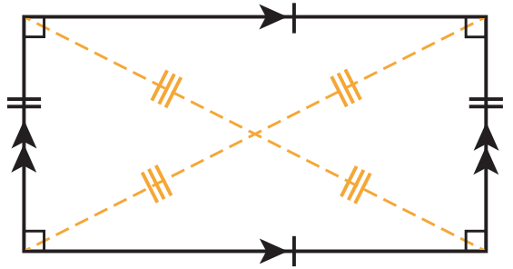 | Rhombus  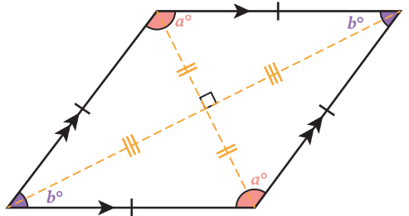
Parallelogram  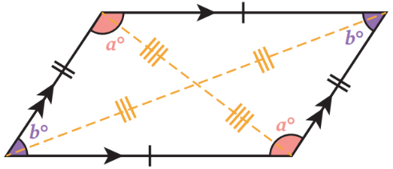 | 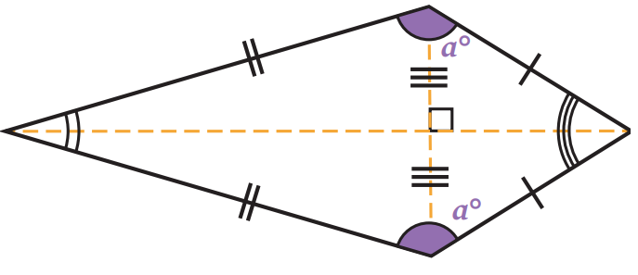  Kite | Trapezium  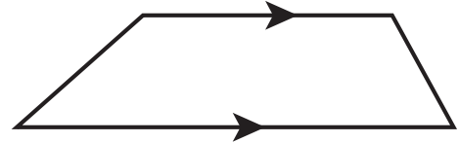
Property (always true?) | Square | Rectangle | Rhombus | Parallel-ogram | Kite | Trapezium
Opposite sides parallel | Yes | Y | Y | Y | No | 1 pair
Adjacent sides equal | Yes | Y | Y | N | 2 pairs | N
Opposite sides equal | Yes | Y | Y | Y | No | N
Opposite angles equal | Yes | Y | Y | Y | 1 pair | N
Adjacent sides perpendicular | Yes | Y | Y | N | No | N
Diagonals bisect the other diagonal | Yes | Y | Y | Y | 1 pair | N
Diagonals intersect at right angles | Yes | N | Y | N | Yes | N
Diagonals equal | Yes | Y | N | N | No | N
Diagonals bisect angles of the quadrilateral | Yes | N | Y | N | 1 pair | N

- Hierarchy of Quadrilaterals
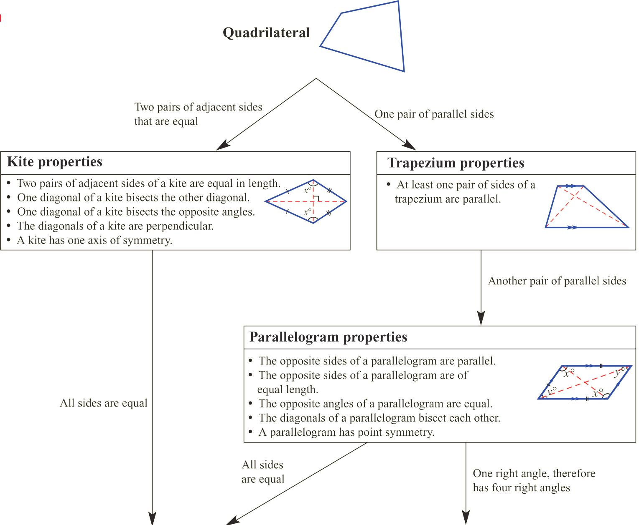

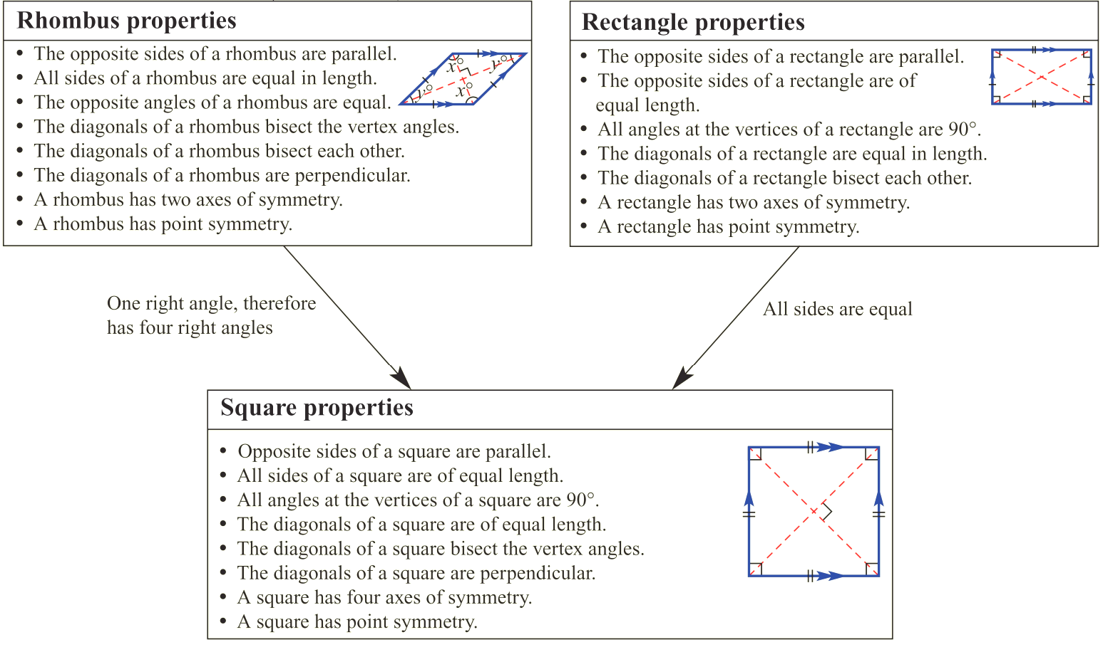

Foundation
- Identify the quadrilateral using its angle properties.
Circle ALL of the shapes the quadrilaterals could be classified as.
Quadrilateral kite | 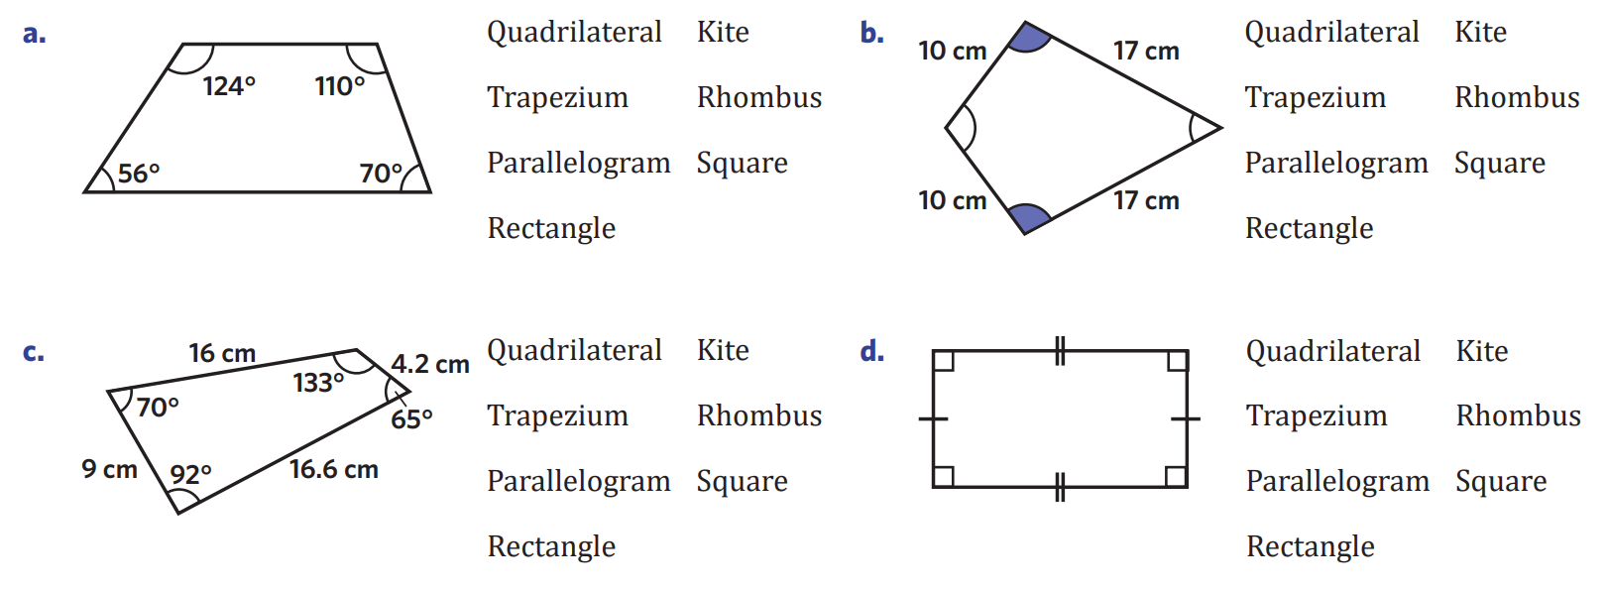  Quadrilateral, parallelogram, rectangle
quadrilateral | Quadrilateral, trapezium

- Name these special quadrilaterals using the most appropriate definition.
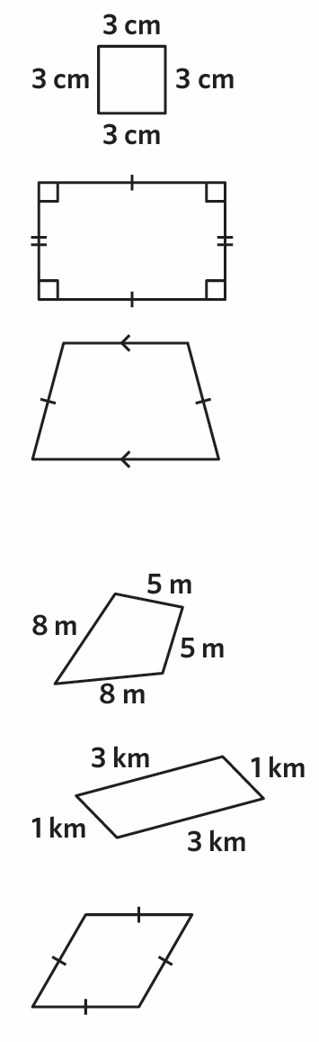  square | rectangle | trapezium | kite
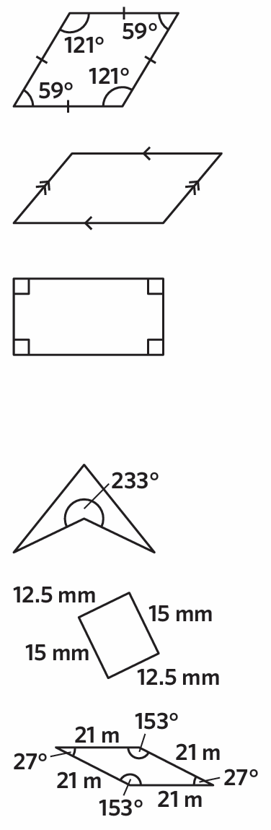  parallelogram | parallelogram | rectangle | rhombus

- Explain why a square is a special type of rectangle.

A square has all the properties of a rectangle
- Explain why a rectangle is not a type of square.

A rectangle does not have all the properties of a square; it does not have equal sides.
- By considering the properties of special quadrilaterals, decide if the following are always true.
  - A square is a type of rhombus. ………………………
true
  - A rectangle is a type of parallelogram. ………………………
true
  - A parallelogram is a type of square. ………………………
false
  - A rhombus is a type of parallelogram. ………………………
true
  - A parallelogram is a type of rhombus. ………………………
false
  - A rhombus is a type of kite. ………………………
true
- Sketch a:
- trapezium ABCD,  with AB parallel to CD  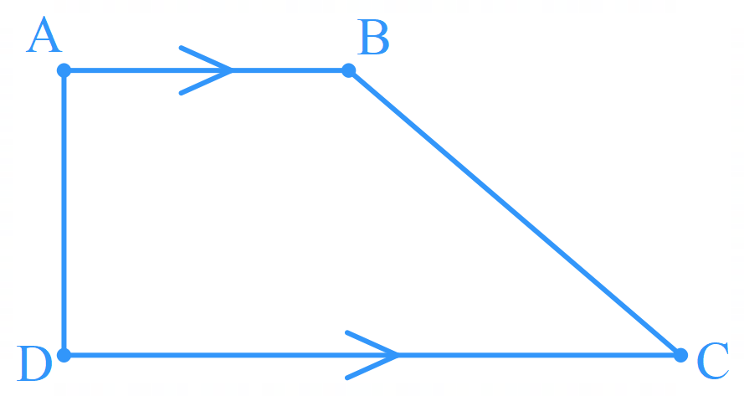 | - trapezium ABCD,  with $∠$ABC acute  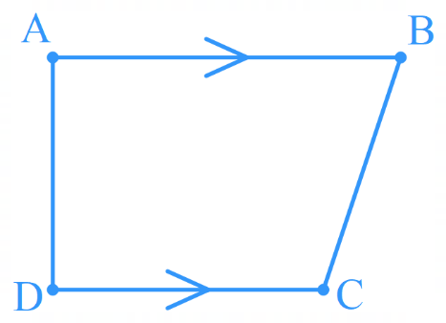 | - kite, PQRS, with $∠$PQR and $∠$PSR both obtuse  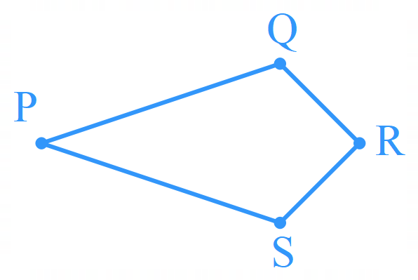

- Find the missing angles. You will need to use properties of quadrilaterals.
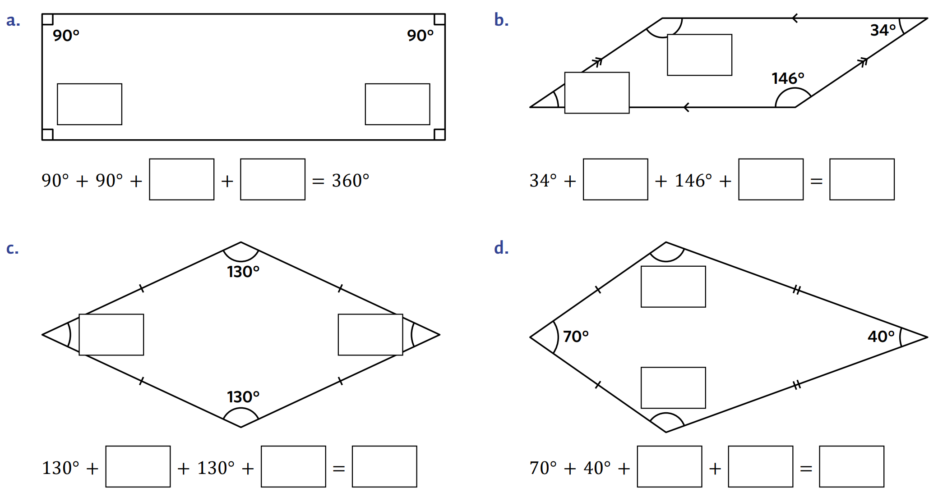  90°, 90° | 34°, 146°
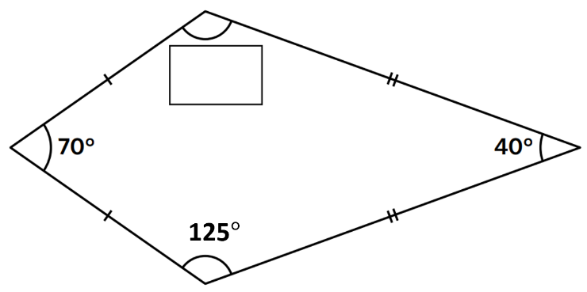  125° | 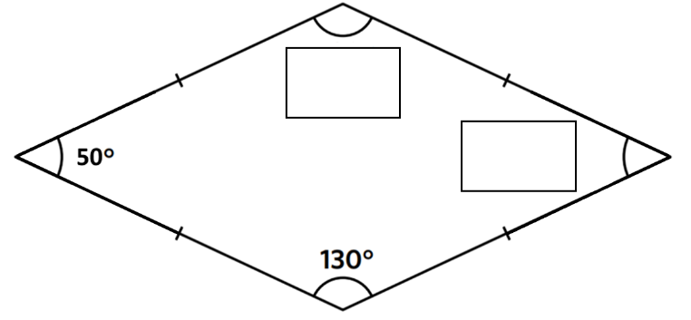  130°, 50°

Development
- First identify the quadrilateral, then determine the values of the angles.
- Quadrilateral:  …………………………  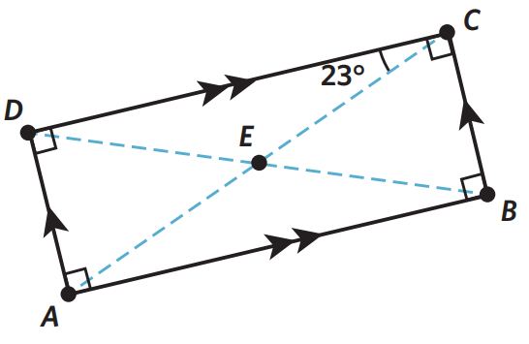  $∠ECB=$ ………………  Rectangle  67° | 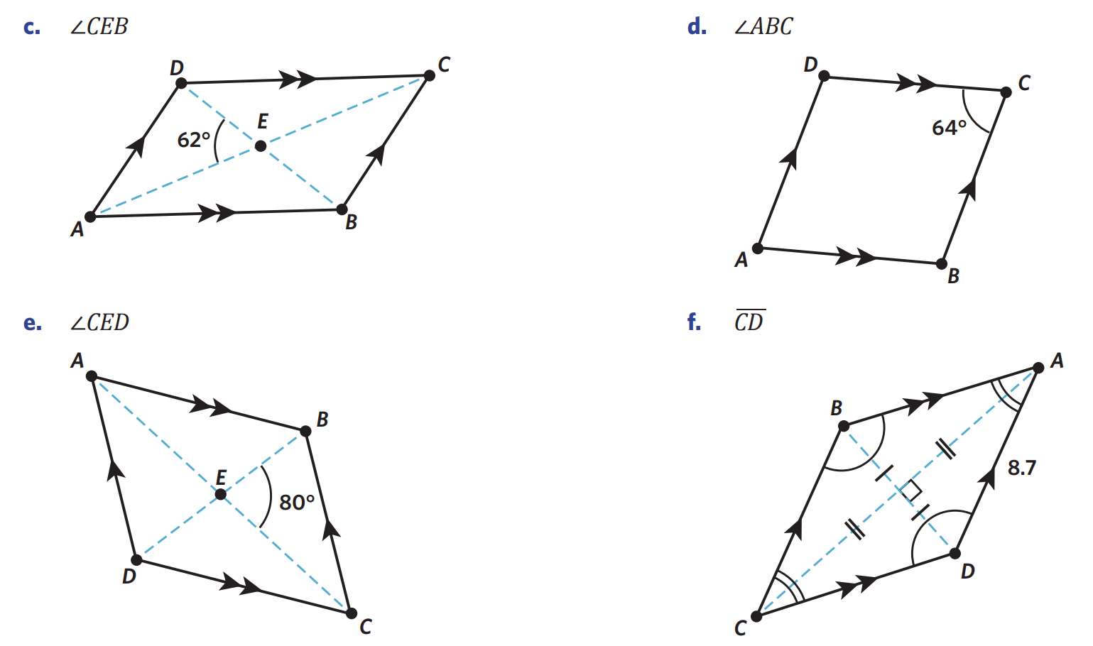  - Quadrilateral:  …………………………  $∠CEB=$ ………………  Parallelogram  62° | - Quadrilateral:  …………………………  $∠ABC=$ ………………  Parallelogram  116°
- Quadrilateral:  …………………………  - $∠CED=$ ………………  Parallelogram  100° | 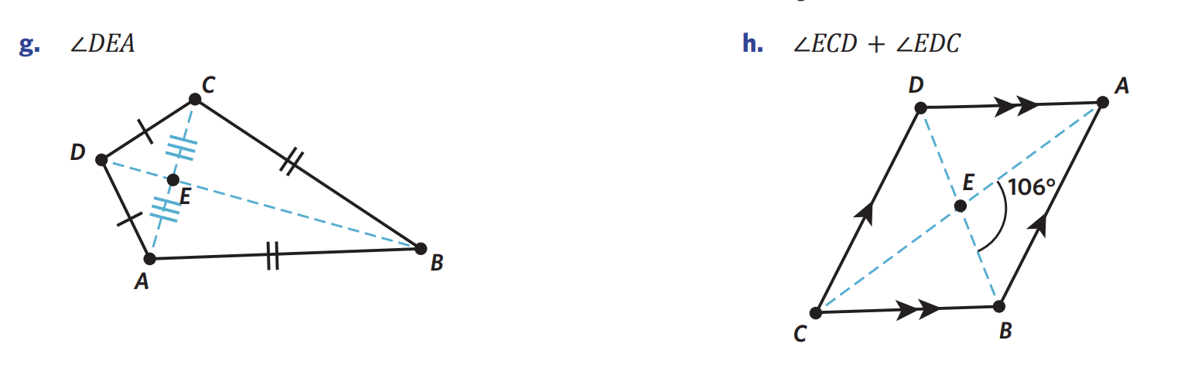  - Quadrilateral:  …………………………  - $∠DEA=$ ………………  Kite  90° | - Quadrilateral:  …………………………  - $∠ECD+∠EDC=$ ………  Parallelogram  74°

- Use the properties of quadrilaterals to find the values of the pronumerals, giving reasons.
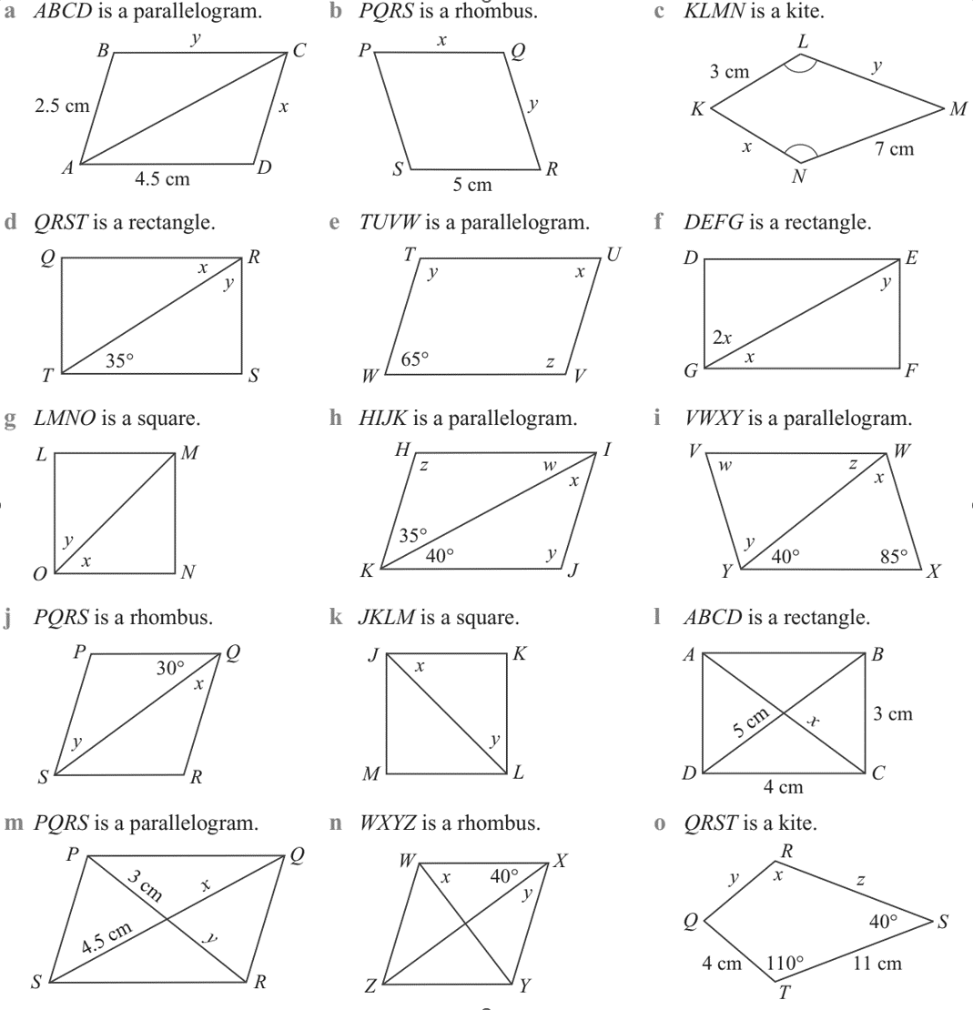  $x=2.5$ cm (opposite sides of a parallelogram equal)  $y=$ ……… (…………………..  …………………………………)  4.5 cm (opposite sides of parallelogram equal) | $x=y=5$ cm  All sides of rhombus equal | $$x=3$$  $$y=7$$  Adjacent sides of kite are equal
$x=35°$ Alternate angles on parallel lines  $y=55°$ complementary with $x$ | $y=115°$ Cointerior angles in parallel lines  $z=115°$ Cointerior angles in parallel lines  $x=65°$ opposite angles in parallelogram equal | $3x=90$ angles in a rectangle  $$x=30°$$  $y=2x$ alternate angles on parallel lines  $$x=60°$$
$x=y$ diagonals of square bisect angles at  $x+y=90°$ (angles in a square)  $$x=y=45°$$ | $x=35°$, $w=40°$  alternate angles on parallel lines  $z=105°$ cointerior angles in parallel lines  $y=z=105°$  opposite angles of parallelogram equal | $z=40°$ alternate angles on parallel lines  $y=55°$ cointerior angles on parallel lines  $x=y=55°$ alternate angles on parallel lines  $w=85°$ opposite angles of paralogram
$x=30°$  diagonals in rhombus bisect angles at vertex  $y=x=30°$ alternate angles on parallel lines | $x=y=45°$  diagonals in square bisect angles at vertex | $x=5$ cm diagonals of rectangle are equal and bisect each other.
$$x=4.5 cm, y=3 cm$$  Diagonals of parallelogram bisect each other | $y=40°$ diagonals of rhombus bisect angles at vertex  $x=50°$ angle sum of triangle | $x=110°$ opposite angles of kite between unequal sides equal.  $y=4$ cm, $x=11$ cm,  adjacent sides of kite equal

Mastery
- NAPLAN B+
The diagram shows a parallelogram $ABCD$. Prove that $ΔBCE$ is equilateral.
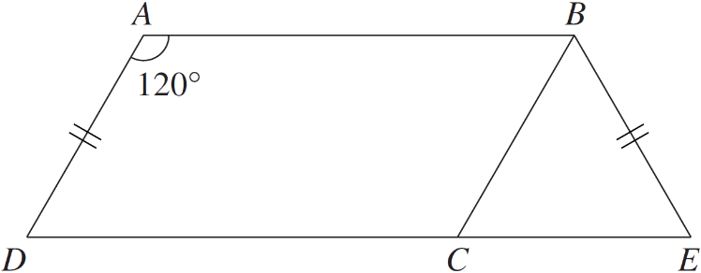

$∠BCD=120°$ opposite angles of parallelogram equal.
$∠ECB=60°$ angles on a straight line
$BC=AD$ opposite sides of parallelogram equal.
$∴BC=AD=BE$, so $ΔBCE$ is isosceles
$∴∠BCE=∠BEC=60°$ angles opposite equal sides of isosceles triangle are equal
$∠BCE=180-60-60=60°$ angle sum of triangle
$∴ΔBCE$ is equilateral, as all angles are 60°
- The length of the diagonals of a rhombus is 24 cm and 18 cm.
Find the length of each side of the rhombus.
(Hint: use Pythagoras’ Theorem)

The diagonals form 4 right-angled tringles where the perpendicular sides are 12 cm and 9 cm.
The hypotenuse is the side length of the rhombus.
$l=\sqrt{{12}^{2}+9^{2}}=15$ cm
- The side of a rhombus is 5 cm.
The length of one diagonal of the rhombus is 8 cm.
Find the length of the other diagonal.

The diagonals form 4 right-angled tringles where the hypotenuse is 5 cm and one of the shorter sides is 4 cm.
The other diagonal is double the other side length.
$$l=\sqrt{5^{2}-4^{2}}=3$$
6 cm

Angle Sum of a Quadrilateral

- Angle Sum of a Quadrilateral
Every quadrilateral can be split into two triangles.
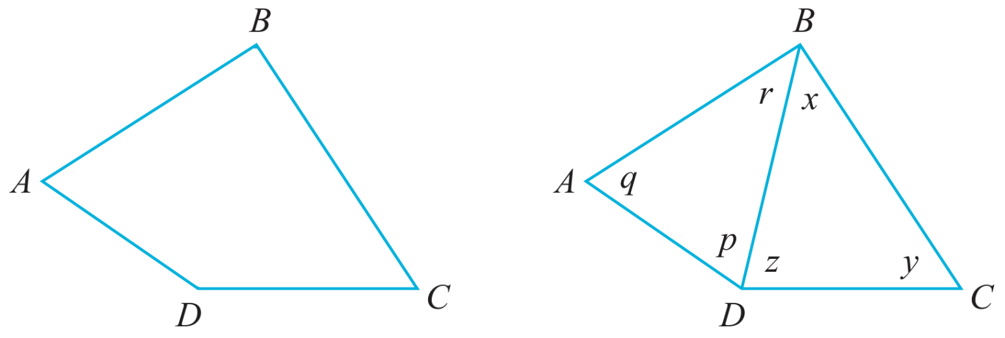

By considering $ΔABD$, $q+p+r=$ 180$°$ (…………………………………………………)
By considering $ΔBCD,$ $x+y+z=$ ………… (…………………………………………………)

So, the sum of all angles in a quadrilateral is
$\left(q+p+r\right) + \left(x+y+z\right)$
$=$ ……………… $+$ ………………
$=$ ………………

- Angle Sum of a Quadrilateral
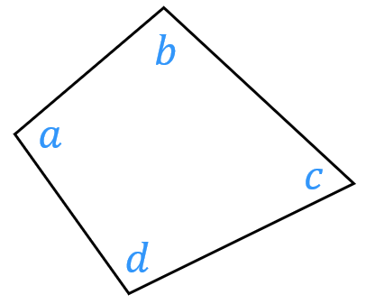

$a+b+c+d=360°$

- Write an equation using angle relationships.
- Simplify the equation, if needed.
- Solve for the unknown using inverse operations.

- Example Solve problems involving the angle sum of a quadrilateral
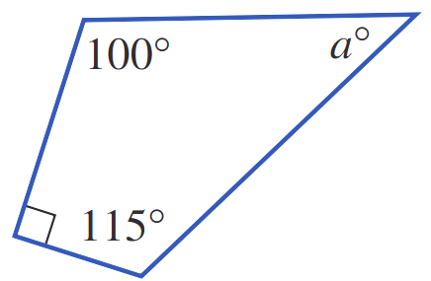  1. $a+90+100+115=360$ (angle sum of quad)  2. $a+305=360$3. $a=55$ | 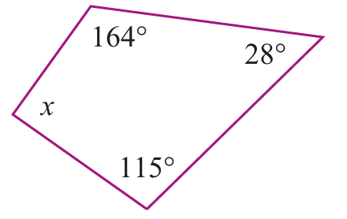  1. $x+164+115+28=360$ (angle sum of quad)  2. $x+307=360$3. $x=53$

- Guided Practice
Find the value of the pronumerals in these quadrilaterals.
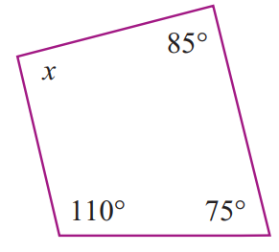  $x+$ ….. + ….. + ….. = ……  $x+$ ….. $=$ ……  $x=$ ……  $x=90°$ | 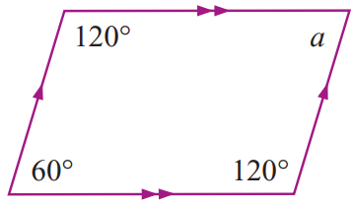  $a+$ ….. + ….. + ….. = ……  $x=60°$

Foundation
- Determine the size of each unknown angle in these quadrilaterals.
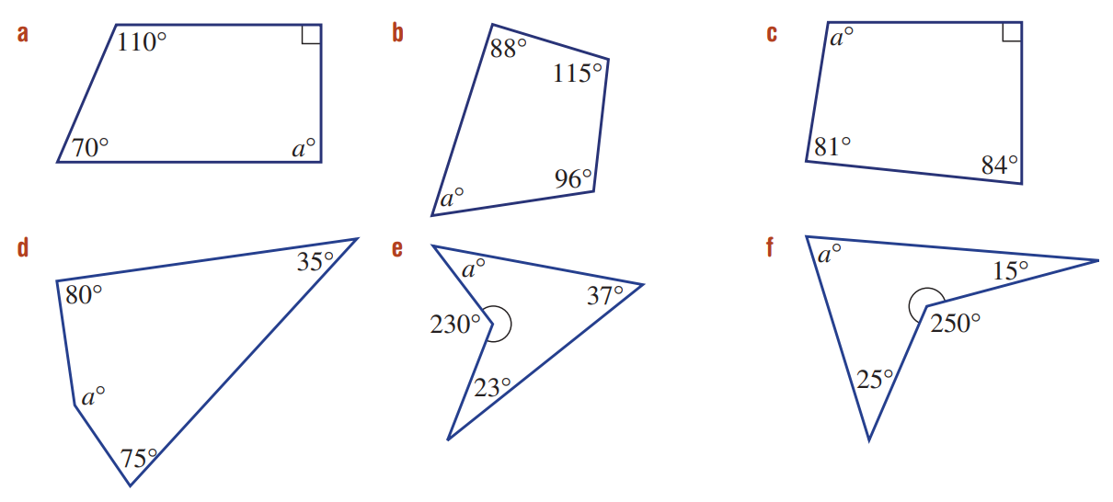  90 | 61 | 105
170 | 70 | 70

- Using your knowledge of co-interior angles, determine the value of these pronumerals.
$$a=104,b=76$$ | 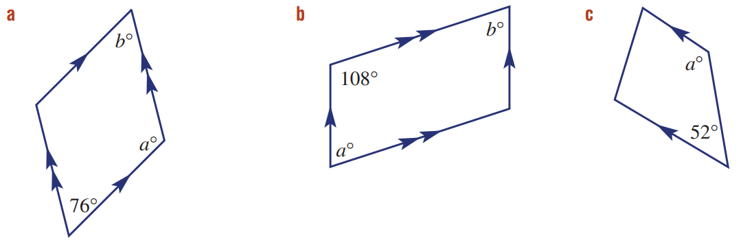  $$a=72, b=72$$ | $$a=128$$

- Using properties of special quadrilaterals, determine the value of these pronumerals.
$$a=100, b=3, c=110$$ | $$a=2, b=90$$ | 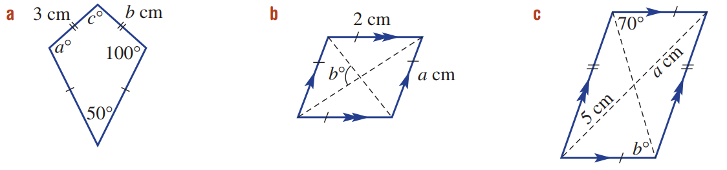  $$a=5, b=70$$

Development
- Find the value represented by the pronumeral.
60 | 90 | 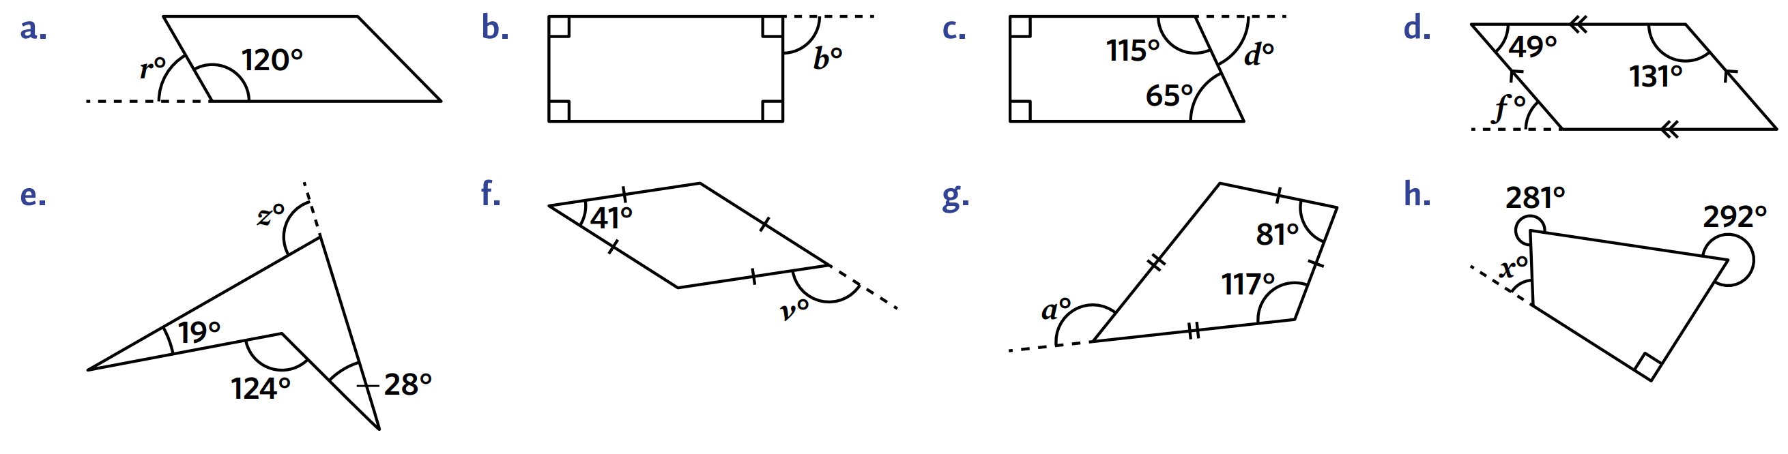  65
103 | 139 | 135
49 | 57

- Find the values of the pronumerals.
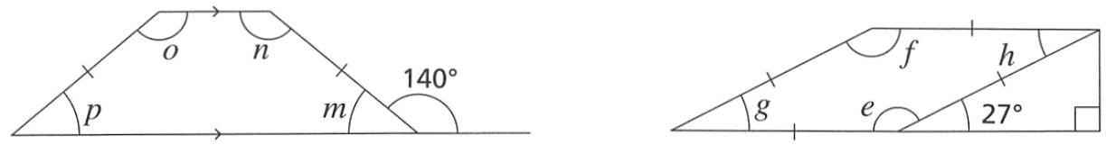  $$e=153, f=153, g=27, h=27$$ | 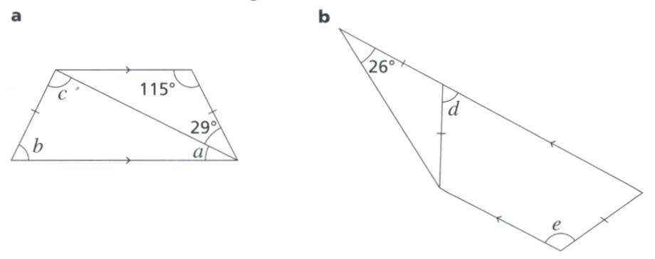  $$d=52, e=128$$

- These two questions involve isosceles trapeziums. Adjacent angles in isosceles trapeziums are equal. Work out the size of each angle labelled with a letter.
$$m=p=40°$$  $$o=n=140°$$ | $$a=36, b=65, c=79$$

- Work out the values of the letters in these diagrams.
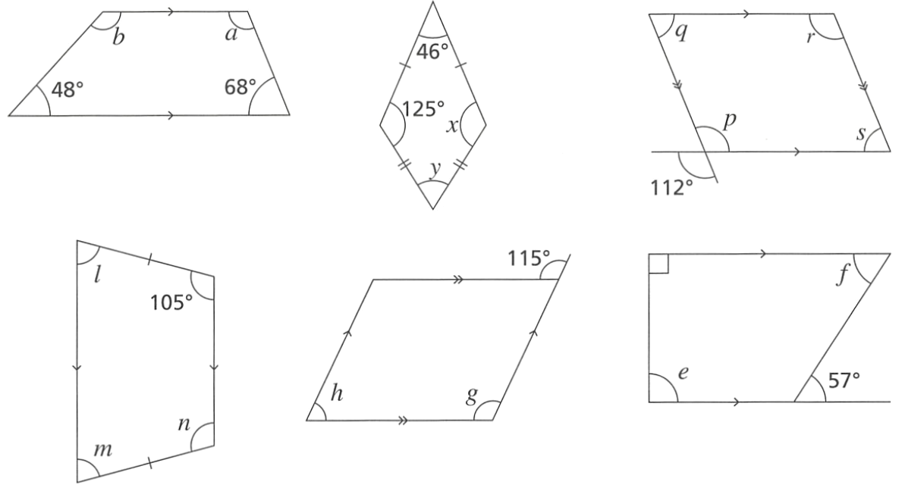  $$a=112°$$  $$b=132°$$ | $$x=125°$$  $$y=64°$$ | $$p=112°, q=68°, r=112°, s=68°$$
$$l=75°, m=75°, n=105°$$ | $$g=115°, h=65°$$ | $$e=90°, f=57°$$

- Determine the value of these pronumerals using your angle relationships knowledge.
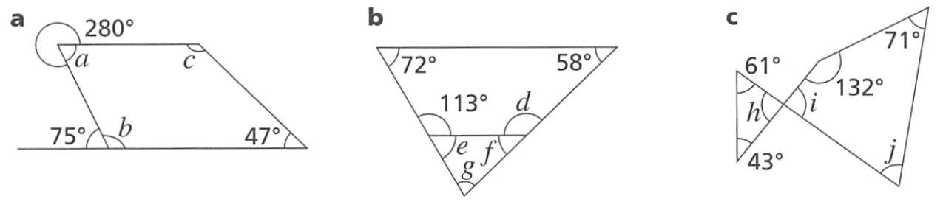  $$a=80°, b=105°, c=128°$$ | $$d=117, e=67, f=63, g=50$$ | 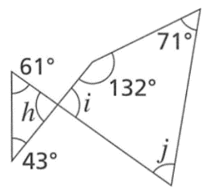  $$h=i=76,j=81$$
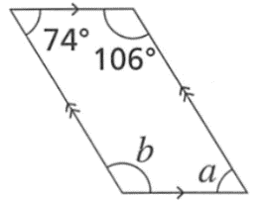  $$a=74, b=106$$ | 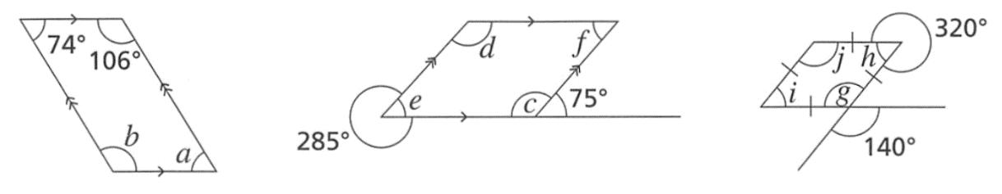  $$c=d=105°, e=f=75°$$ | $$i=h=40°, j=g=140°$$

- Determine the value of these pronumerals using your angle relationships knowledge.
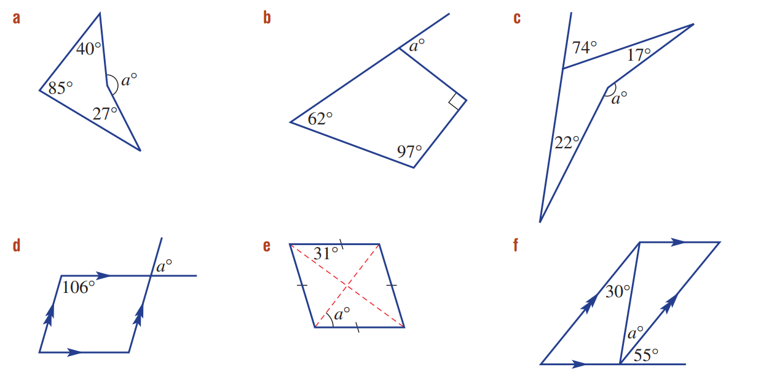  152 | 69 | 74
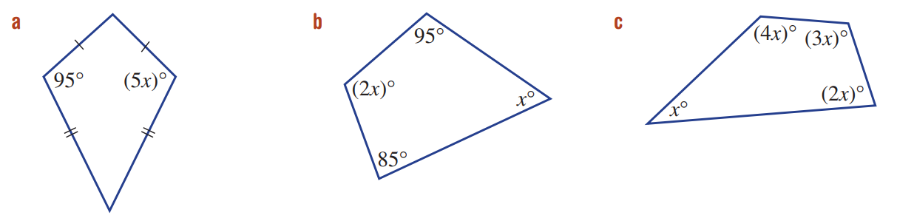  19 | 60 | 36
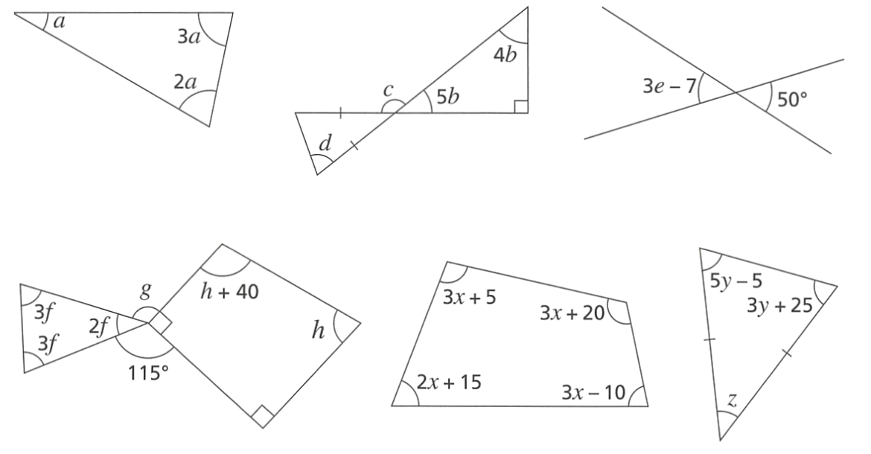  30 | $$b=10, c=130, d=65$$ | 19
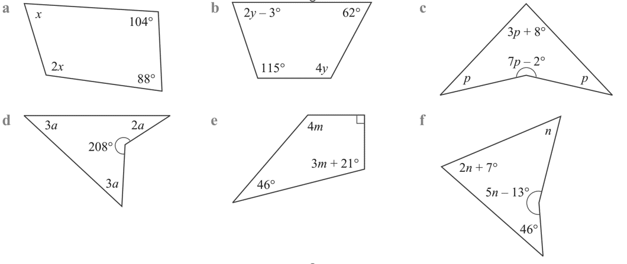  56 | 31 | 29.5
19 | 29 | 40

- Determine the value of these pronumerals using your angle relationships knowledge.
$$h=70, f=22.5, g=110$$ | 30 | $$y=15, z=40$$
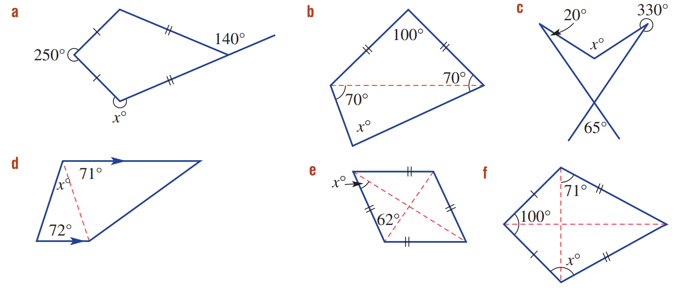  255 | 80 | 115
37 | 28 | 111

Mastery
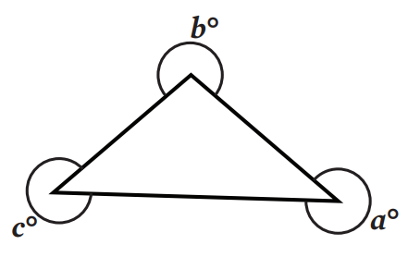
- What is the value of $a+b+c$? Explain your reasoning.
c + x = 360
b + y = 360
a + z = 360
c + x + b + y + a + z = 1080
a + b + c = 1080 - (x + y + z)
x + y + z = 180
∴ a + b + c = 1080 - 180 = 900°

- The diagram has an equilateral triangle inside a rectangle. Determine the value of $a+b$. Explain your reasoning.
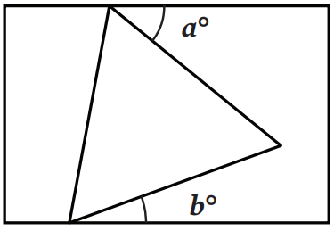

Construct line AB at C parallel to sides of rectangle
x = a and y = b (alternate angles on parallel lines)
x + y = 60° (angles in equilateral △)
∴ a + b = 60°

- Determine the value of $a$ in this diagram. Explain your reasoning.
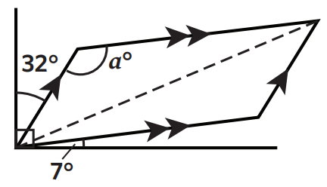

b = 90 - 32 - 7 (angles in right-angle)
= 51°
2a + 2b = 360 (angle sum of quad)
2a = 360 - 2b = 360 - 2(51)
2a = 258°
∴ a = 129°
- Determine the value of $a$ in this diagram. Explain your reasoning.
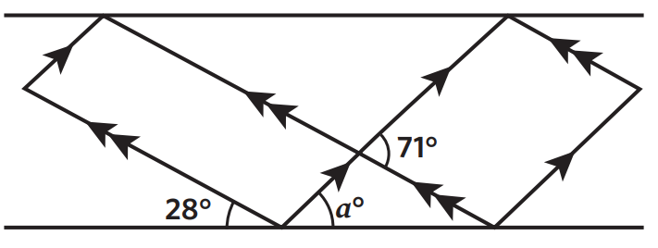
2x + 71 + 71 = 360 (angle sum of quad)
2x = 218
x = 109
a + 28 + 109 = 180 (angles on straight line)
a = 43°
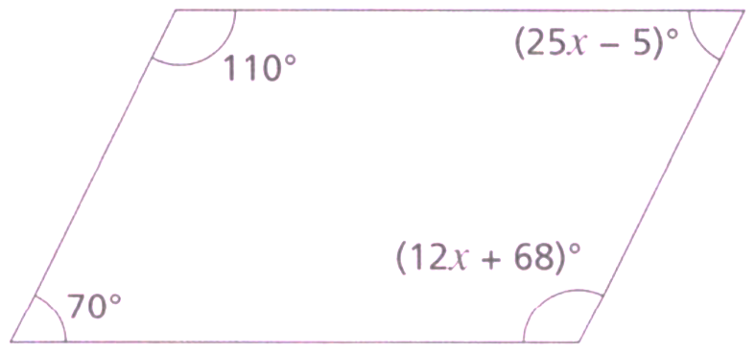
- Is this shape a parallelogram? Explain your reasoning.
If parallelogram, then co-interior angles equal
110 + 25x - 5 = 180
25x = 75
x = 3
check using the other pair of cointerior angles 70 + 12x + 68 = 180
70 + 12(3)+ 68 = 174 ≠ 180
∴ not parallelogram

Mixed Practice

Foundation
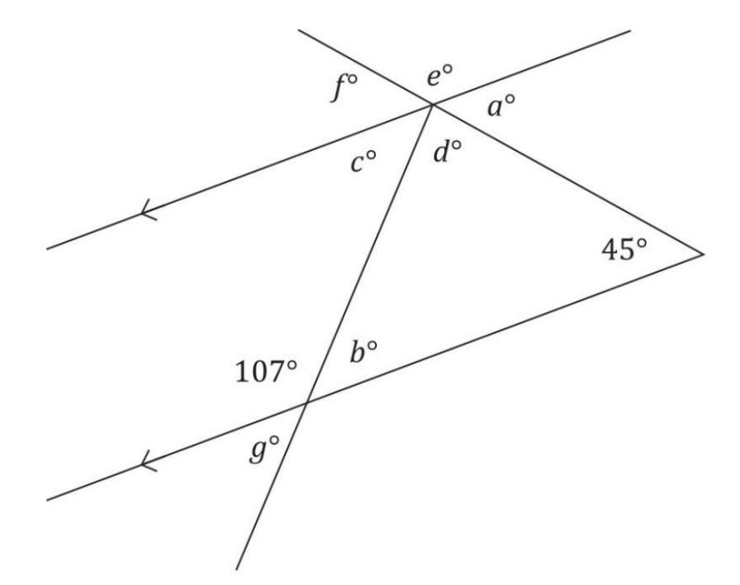
- Determine the value represented by each pronumeral.

$$a=45, b=73, c=73, d=62, e=135, f=45, g=73$$
- Determine the sizes of all the unknown angles.
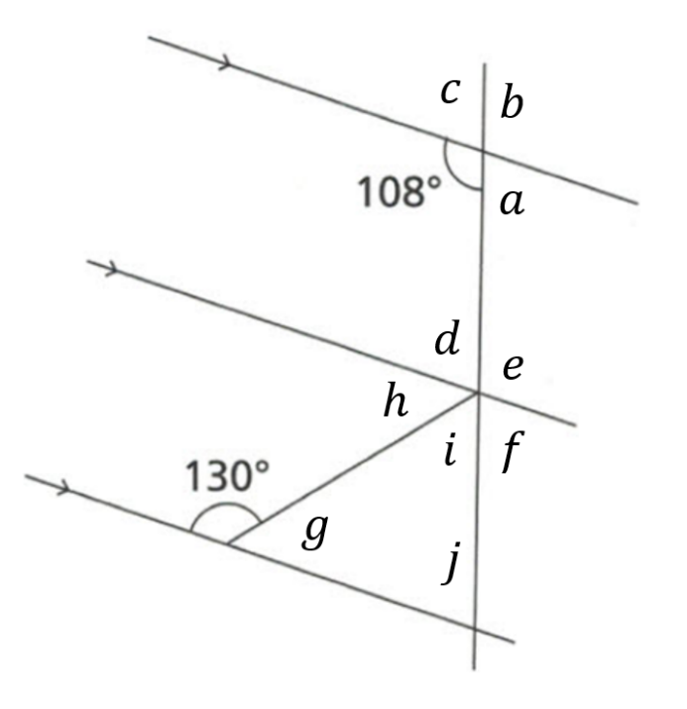  $$a=72$$  $$b=108$$  $$c=72$$  $$d=72$$  $$e=108$$  $$f=72$$  $$g=50$$  $$h=50$$  $$i=58$$  $$j=72$$ | 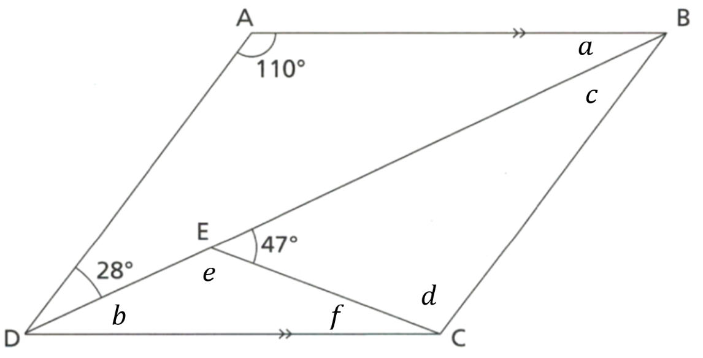  $$a=42$$  $$b=42$$  $$c=28$$  $$d=105$$  $$e=133$$  $$f=5$$
- Work out the values of the pronumerals.
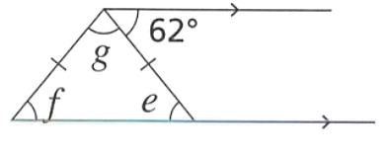  $$e=62, f=62, g=56$$ | 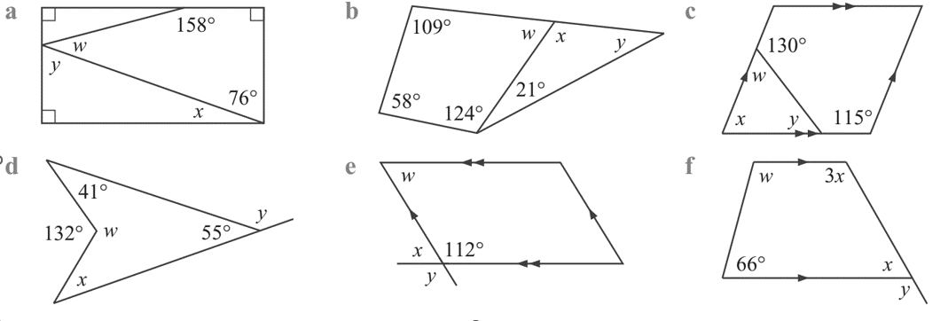  $$x=14, y=76, w=36$$ | $$w=69, x=111, y=48$$
$$w=50,x=65, y=65$$ | $$w=228, x=36, y=125$$ | $$x=45, w=114, y=135$$

Development
- Work out the size of angles $a$ and $b$.
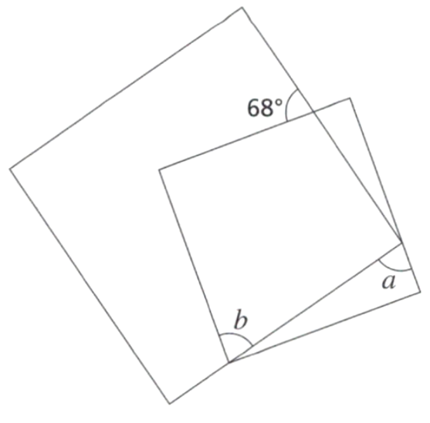  - Two overlapping squares  $$a=b=68°$$ | 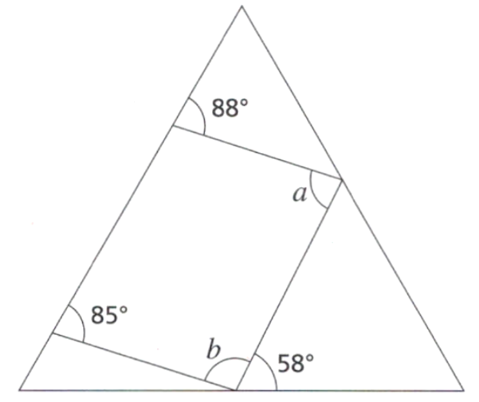  - Quadrilateral inside an equilateral triangle  $$a=86°, b=97°$$

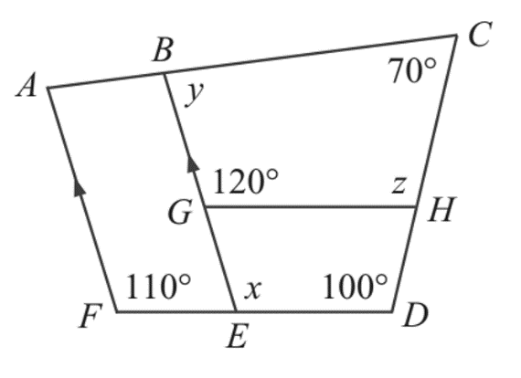
- Find the values of the pronumerals. Provide full reasoning.

$$x=110°\left(corresponding angles on parallel lines\right)$$
$$∠EGH=60°\left(angle sum of straight line\right)$$
$$∠GHD=90°\left(angle sum of quadrilaterial\right)$$
$$z=90°\left(angle sum of straight line\right)$$
$$y=80°\left(angle sum of quadrilaterial\right)$$
- Juna is exploring angles by folding rectangular strips of paper.
Work out the size of each angle marked $x$.
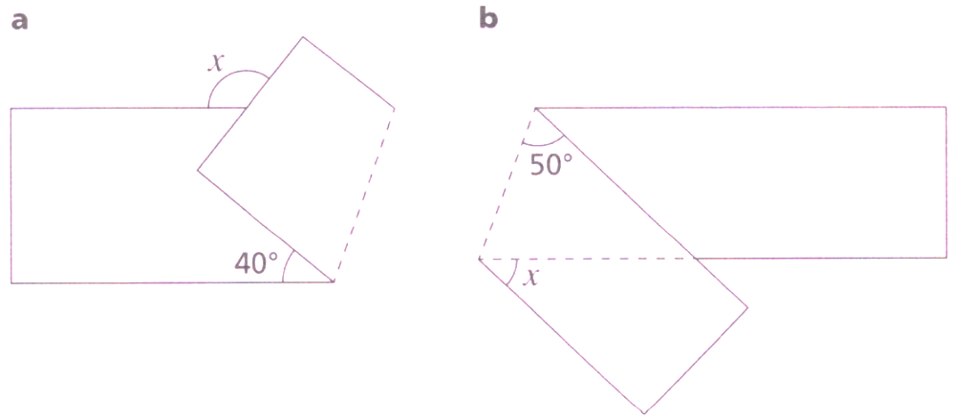  $$x=80$$ | $$x=130$$

- Find every angle you can.
- PQRS is a square and PQT is an equilateral triangle.  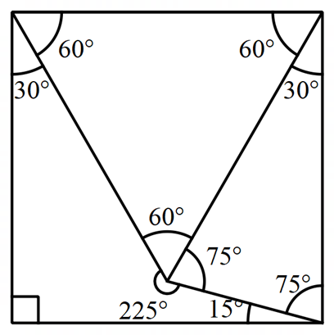  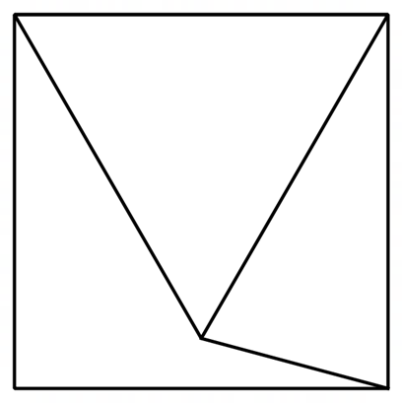 | - This diagram shows two overlapping parallelograms.  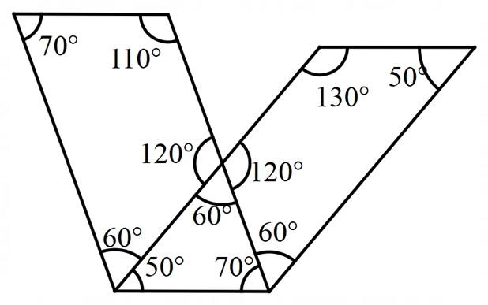  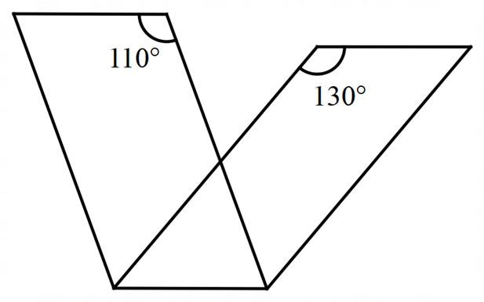
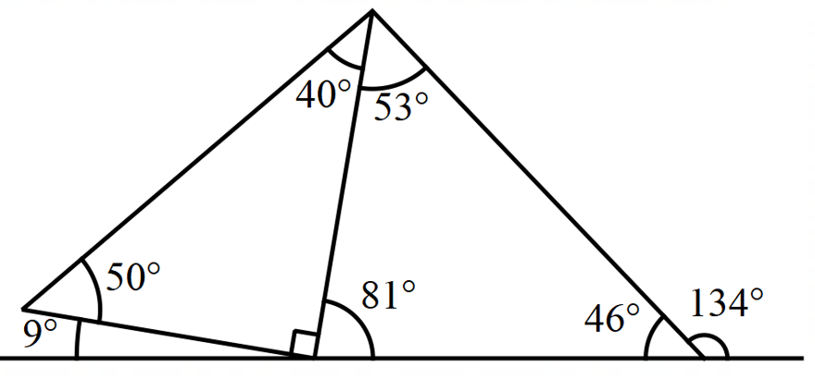  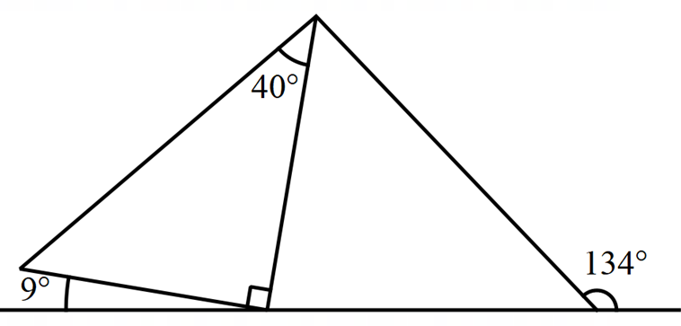 | 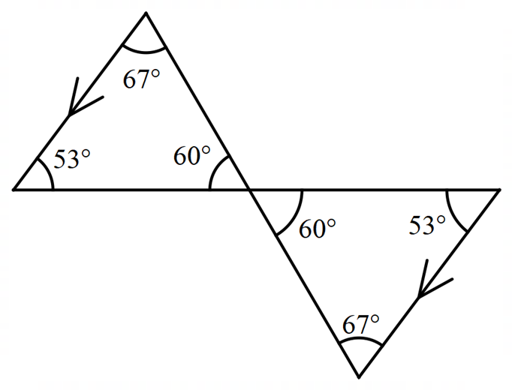  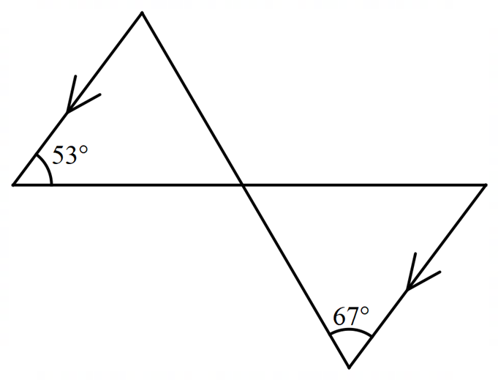

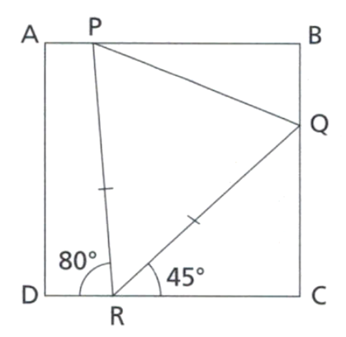
- The diagram shows a triangle in a square. Find the size of $∠BQP.$ Provide full reasoning.

$∠$PRQ = 55° (angles on a straight line add up to 180°)
$∠$RQP = 62.5° (angles in a triangle add up to 180° and two angles in an isosceles triangle are equal)
$∠$CQR = 45° (angles in a triangle add up to 180°)
$∠$BQP = 72.5 ° (angles on a straight line add up to 180°)

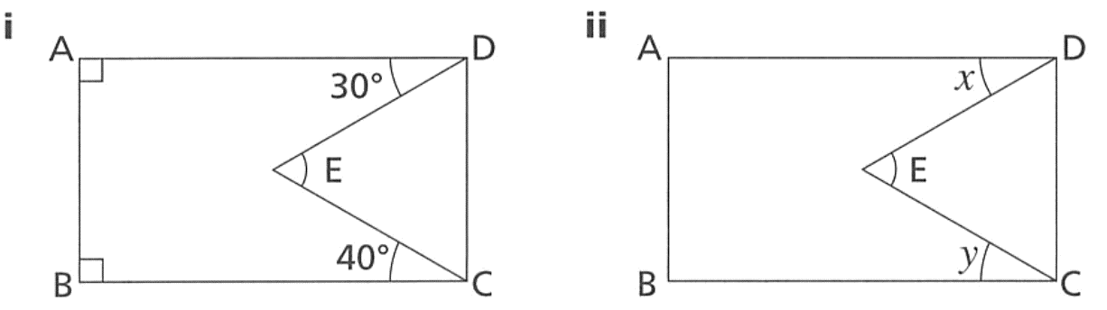
- In both diagrams, ABCD is a rectangle.

  - Using diagram i, prove that $∠DEC = 70°$. Provide full reasoning.
$∠$EDC = 90° - 30° = 60° (angles in a rectangle are right angles)
$∠$ECD = 90°- 40° = 50° (angles in a rectangle are right angles)
$∠$DEC = 180°-(60° + 50°) = 70° (angles in a triangle add up to 180°)

  - Using diagram ii, prove that $∠DEC=(x+y)$
$∠$EDC = 90° - x (angles in a rectangle are right angles)
$∠$ECD = 90°- y (angles in a rectangle are right angles)
So $∠$EDC + $∠$ECD = 180°-(x + y)
$∠$DEC = x + y (angles in a triangle add up to 180°)

- Prove that $∠BEC=30°$  $∠$BEF = 110° (co-interior angles add up to 180°)  $∠$AEF = 80° (corresponding angles are equal)  $∠$BEC = 110°- 80° = 30° | - Prove that $∠BEC=180°-(x+y)$  $∠$BEF = 180°- x (co-interior angles add up to 180)  $∠$AEF = y (corresponding angles are equal)  $∠$BEC = (180°- x) - y = 180°- (x + y)

- Prove that that $∠PQR=(2a-180)$  $∠$PRQ = 180° – a (angles on a straight line add up to 180)  $∠$QPR = 180° – a (base angles in an isosceles triangle are equal)  $∠$PQR = 180° – (180° – a + 180° – a)  = (2a – 180)° (angles in a triangle add up to 180°) | 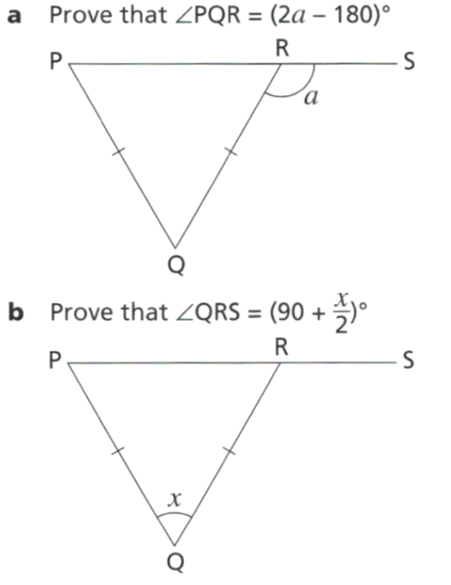  - Show that $∠QRS=\left(90+\frac{x}{2}\right)$  $∠$PRQ = $\frac{180-x}{2}$ (base angles in an isosceles triangle are equal)  $∠$QRS = 180 – $\frac{180-x}{2}$ (angles on a straight line add up to 180°)  $$=90+\frac{x}{2}$$

- In each diagram, work out the value of each pronumeral.
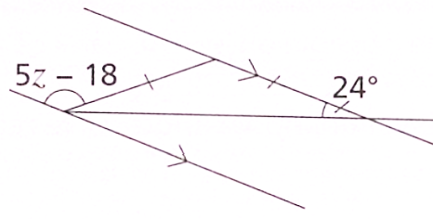  $$z=30$$ | 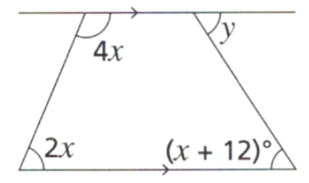  $x$ = 30°, $y$ = 42° | 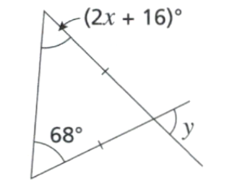  $x$ = 26°, $y$ = 44°

Mastery
- Show that this shape is a parallelogram. Justify your answer clearly.
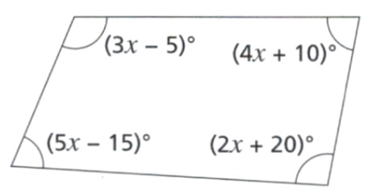

Using angle sum of quadrilateral, $x=25$
If this is a parallelogram, then $5x-15+2x+20=180$
And $3x-5+4x+10=180$
And $3x-5+5x-15=180$
And $4x+10+2x+20=180$
Because they would be co-interior.
By substituting $x=25,$ all these equations are true, so there are two pairs of parallel sides,
and therefore the quadrilateral is a parallelogram.

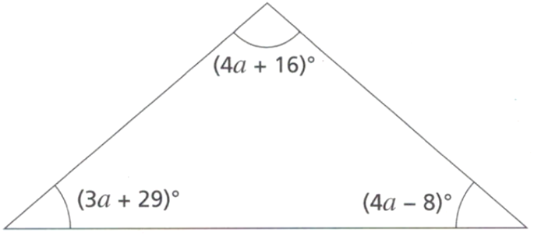
- Show that this triangle is isosceles.

Using angle sum of triangle, $a=13$
$$3a+29=3\left(13\right)+29=68$$
$$4a+16=4\left(13\right)+16=68$$
Therefore isosceles as it has two equal angles.

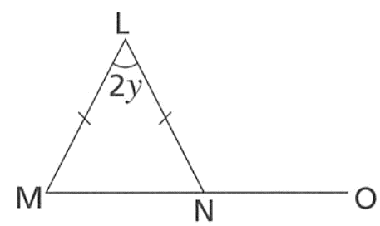
- Prove that $∠LNO=90°+y$

ZLNM = $\frac{180 - 2y}{2}$ (angles at the base of an isosceles triangle are equal)
So $∠$LNM = 90°- y
$∠$LNM + $∠$LNO = 180°
(adjacent angles on a straight line add up to 180°)
So 90°-y + $∠$LNO = 180°,
so $∠$LNO = 90° + y

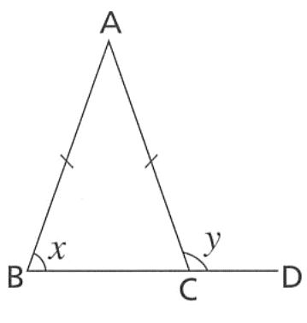
- Consider the diagram to the right.
  - Prove that $y=180°-x$

$∠$ACB = x (angles at the base of an isosceles triangle are equal)
ZACB + ZACD = 180°
(adjacent angles on a straight line add up to 180°)
So x + y = 180°, so y = 180° - x
  - Prove that $∠BAC=180°-2x$

$∠$BAC + $∠$ABC + $∠$ACB = 180°
(angles in a triangle add up to 180°)
So $∠$BAC + x + x = 180°,
so $∠$BAC = 180°- 2x

- Prove that $x+4y=180°$
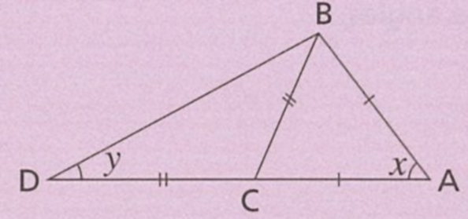
$∠$CBD = y (angles at the base of an isosceles triangle are equal)
$∠$BCD = 180 -2y (angles in a triangle add up to 180°)
$∠$BCA = 2y (adjacent angles on a straight line add up to 180°)
$∠$ABC = 2y (angles at the base of an isosceles triangle are equal)
In triangle ABC, $∠$BCA + $∠$ABC +
$∠$CAB = 180° (angles in a triangle add up to 180°)
So 2y + 2y + x = 180°,
hence x + 4y = 180°

- Find the value of $x$ in these diagrams.
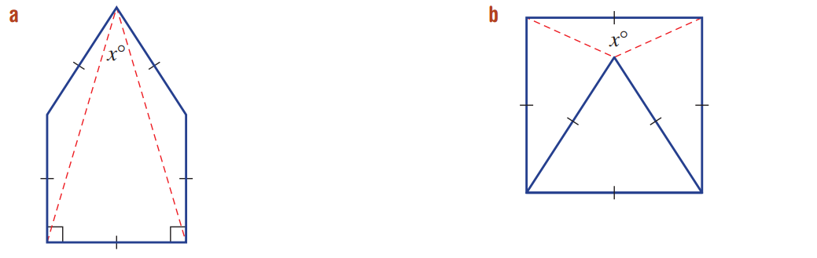  $$30°$$ | $$150°$$

